Channel model of ceramic plate heating with help of microwave space
P.V. Kozlov, E.B. Kulumbaev, V.M. Lelyovkin
Kyrgyz-Russian Slavic University, Kyrgyzstan, Bishkek
The analytical solution of Maxwell’s equation and energy balance for ceramic plane, heating in field of normally incident, plate wave of microwave range, is constructed in channel coefficient approximation of electric and heat conductivity of ceramic materials.
The distributions of electric field strength and temperature across plate, under the assumption of symmetrical supply of microwave capacity are shown in formulas:
$$T(x)=T_{0}−\frac{σ_{0}E_{0^{2}}}{8λ_{0}}(\frac{{\text{sh}}^{2}\text{ax}}{a^{2}}+\frac{{\text{sin}}^{2}\text{bx}}{b^{2}}),\begin{matrix}\begin{matrix} & E(x)=E_{0}\end{matrix}\text{cos}(\text{kx})\text{.}\end{matrix}$$
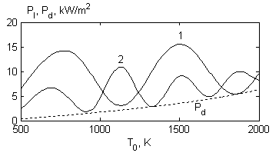
The results of computation of stationary thermal conditions for ceramics, based on aluminum oxide are shown on picture. The temperature character of conducting microwave radiation capacity is take part in this case. The reflective coat infliction on one of side surface of plate increases the coefficient of efficiency of ceramic heating.
Connection between leading capacity P₁, dissipated capacity P_{d}, and temperature in the center of plate. 1 – symmetrical supply of capacity, 2 – plate with reflecting layer. Field frequency f=50 GHz.

