PROJECT OF new-generation open trap in INP: "TRAP WITH turbulenT PLUGs"
A.D. Beklemishev
Institute of Nuclear Physics SB RAS, Novosibirsk, Russia, e-mail: bekl@inp.nsk.su
During the last decade significant progress has been achieved in plasma confinement in axially symmetric open traps. In particular, the multiple-mirror confinement in the GOL-3 device appears to work well even at much lower plasma densities than originally predicted due to anomalous (turbulent) scattering of ions. This makes the whole concept applicable for plasmas with β<1. In GDT, the two-component plasma with hot sloshing ions was successfully confined with β~0.6 and T_{e}~200eV. Now both these traps appear to have reached their design limits, so that planning of the next step becomes necessary. This step should be common for both research directions, due to scarcity of available resources but also due to their natural convergence. It turned out that the scheme of GDT is excellent for confining the burning plasma, but the axial losses are too high, while the multiple-mirror scheme is excellent in suppressing axial losses, but lacks plasma volume and sufficient β limits for high-Q operation. The electron-beam heating used in GOL-3 also seems to be a cheap and efficient supplement to the NBI heating. Hence it has been decided to build a trap consisting of a large central mirror cell with multiple-mirror turbulent plugs for better axial confinement. Construction will use existing parts and infrastructure left over from the abandoned project, the “Hydrogen prototype”. Scheme of the proposed trap is shown in Fig.1.
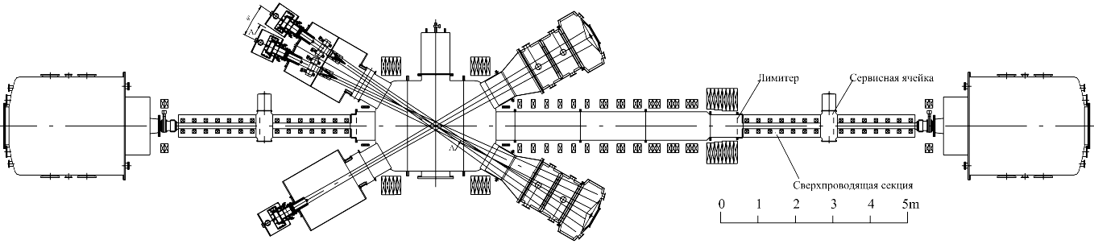
Fig.1.
The main aims of the new trap are: 1) to reach original goals of the “Hydrogen prototype”, namely, the neutron flux density of 2 MW/m² (in recalculation into DT); 2) improving energetic efficiency of generating neutrons, Q_{DT}>0.03, 3) assembling database for future designs of the open-trap-based fusion reactor. Projected plasma parameters: central mirror length is 10m, plasma radius is 0.1m, ion density ~3*10²⁰m⁻³, NBI energy is 40 keV, electron temperature >400 eV, discharge time ~ 1s. The heating power is 10MW in NBI plus the same in electron beams.

