2D3V PARTICLE-IN-CELL SIMULATION OF A MULTIPACTOR DISCHARGE ON A DIELECTRIC IN A RECTANGULAR WAVEGUIDE
Sakharov A.S., Ivanov V.A., *Tarbeeva Yu.A., Konyzhev M.E.
A.M. Prokhorov General Physics Institute, Russian Academy of Sciences, Moscow, Russia,
sakh@fpl.gpi.ru
*NRNU MEPhI, Moscow, Russia
A 2D3V particle-in-cell code for simulation of a multipactor discharge (MD) on a dielectric in a metal rectangular waveguide has been developed. The code is based on solving the equations of motion of electrons in the microwave field and the self-consistent field of electron space charge with allowance for secondary electron emission (SEE) from the dielectric surface and waveguide walls, finite temperature of secondary electrons, and elastic and inelastic electron reflections.
The code makes it possible to simulate different stages of MD development: from the beginning of the electron avalanche up to saturation. The thresholds for the onset of an MD on dielectric surfaces with different SEE characteristics, the electron distribution function, and the fluxes of electrons onto the dielectric surface and waveguide walls are calculated, and the influence of reflected electrons and the SEE characteristics of the waveguide walls on the discharge development is analyzed.
It is shown that the threshold for the onset of an MD on a dielectric placed in a waveguide increases as compared to the case of an unbounded dielectric surface due to electron losses on the waveguide walls. It is found that, depending on the amplitude of the microwave field and SEE characteristics of the waveguide walls, the MD can operate in two different modes. In the first mode, the MD develops only on the dielectric surface, which in this case is charged positively (Fig. 1a). In the second mode, which occurs at microwave intensities exceeding the threshold for the onset of a two-surface MD between the waveguide walls, both the single-surface MD on the dielectric and the two-surface MD between the waveguide walls operate simultaneously. In this case, the region occupied by the two-surface MD rapidly expands along the waveguide axis z and the dielectric surface acquires a negative potential (Fig. 1b).
This work was supported by the RFBR (project nos. 09-08-00753-a, 11-02-00551-a).
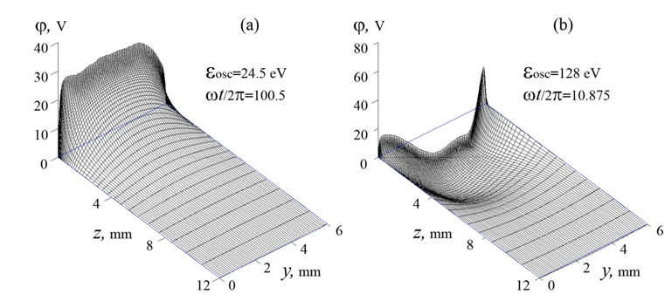
Fig. 1. Two operating modes of an MP on a dielectric placed in a 6-mm high waveguide. The z axis is directed along the waveguide axis, the y axis is directed along the electric vector of the microwave field (parallel to the dielectric surface, located at z = 0), and the waveguide walls are at y = 0 and 6 mm.

