INITIATION OF MICROPLASMA DISCHARGES ON TITANIUM SURFACES COVERED WITH DIELECTRIC FILMS OF DIFFERENT THICKNESS
V.A. Ivanov, M.E. Konyzhev, A.A. Letunov, T.I. Kamolova, A.S. Sakharov, A.A. Dorofeyuk, S.N. Satunin
A.M. Prokhorov General Physics Institute, Russian Academy of Sciences, Moscow, Russia, ivanov@fpl.gpi.ru
Interaction of a pulsed plasma flow (n_{e} > 10¹⁵ cm⁻³) with a negatively biased metal sample in vacuum leads to the excitation of explosive emission and formation of cathode spots on the metal surface [1]. If the metal is partially covered with a dielectric film (or the film has tears), microplasma discharges (MPDs)—local surface breakdowns accompanied by the generation of dense plasma—are excited at the film edge [2, 3]. For a sample potential of ϕ_{i} ≈ −400 V, electron temperature of T_{e} ≈ 10 eV, and film thickness of d ~ 1 µm, the threshold plasma density required for the excitation of MPDs turns out to be as low as n_{e} ≈ 10¹² cm⁻³. This is because the charging of the dielectric surface near the film edge leads to the generation of the electric field at a level of E ~ϕ_{i}/2d ≥ 2 MV/cm [2], which is substantially stronger than the threshold field for surface breakdown (E_{b} ≈ 200–300 kV/cm). MPDs excited at the film edge initiate the formation of cathode spots rapidly propagating over the metal surface. The melting and subsequent fast cooling of the metal by the cathode spots lead to the formation of a microrelief on its surface [3]. The high-strength microrelief formed on the metal surface has potentially wide application in medicine and industry.
The probability P of MPD excitation on the surfaces of titanium samples partially covered with oxide films (TiO₂, ZrO₂) 0.01−12 µm in thickness was studied experimentally. The samples were exposed to a pulsed plasma flow with a density of n_{e} ≈ 10¹³ cm⁻³ and duration of 25 µs. It is found that, for film thicknesses of d ≈ 0.1–2 µm, the probability of MPD excitation on a titanium surface is close to unity. For thinner (d ≤ 0.01 µm) and thicker (d > 10 µm) films, the excitation probability decreases to about 0.01 (see figure). For very thin films, this is explained by the leakage of the electric charge from the film surface and low electric energy density accumulated at the film edge by the instant of breakdown. For thicker films (d > 10 µm), the electric field at the film edge is reduced to a value of E ≈ ϕ_{i}/2d< 200 kV/cm, which is lower than the threshold field for electric breakdown.
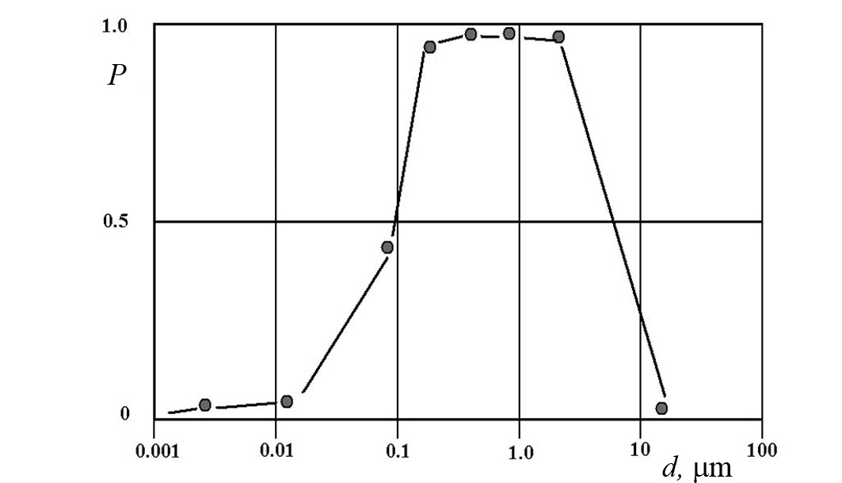
This work was supported by the RFBR, project no. 09-08-00753a.
References
- G.A. Mesyats, Ectons in a Vacuum Discharge: Breakdown, Spark, and Arc (Nauka, Moscow, 2000), p. 55 [in Russian].
- V.A. Ivanov, A.S. Sakharov, M.E. Konyzhev, Plasma Phys. Rep. 34, 150 (2008).
- V.A. Ivanov, M.E. Konyzhev, S.N. Satunin, et al., Prikl. Fiz., No. 6, 76 (2009).

