Research of anomalous electron transport in Hall Thruster (HT) plasma
Goryachev I.A., Levhenko V.D., Perepelkina A. Yu.
Keldysh Institute of Applied Mathematics RAS, Moscow, Russia, kvant87@gmail.com
Most recent development of spacecraft equipment suggests the use of electrically powered propulsion systems and Hall thrusters [1] among them. One of the problems in developing the model of HT plasma phenomena is description of electron transport towards anode. To explain this effect the hypothesis of base kinetic instabilities and plasma turbulence appearance is presented in this work. Analytical description of these effects is conducted in QLT, MHD and Hamiltonian formalism [2]. Numerical experiment is to become verification of this hypothesis.
Fully kinetic model combined with Maxwell equations for self-consistent EM fields is used for plasma processes in HT description.
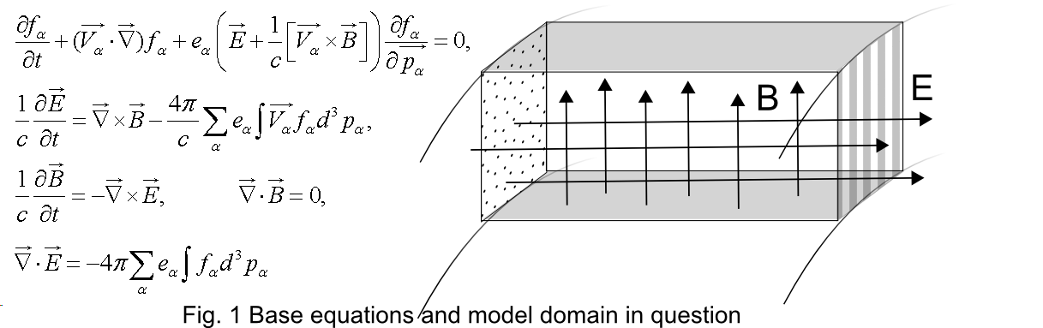
3D box (Fig. 1) as a sector of HT working channel is chosen as a computational model domain. Top and bottom planes of the box represent free surface of a conductor (metal). Periodical boundary conditions are used on front and rear sides of the domain. Right side of domain has electron source (cathode) and is open for particle emission from the box. Left border represents the source of working gas and anode.
Equilibrium state is chosen as initial condition for plasma. Thermal to electron velocities ratio is about V_{Te}/V_{i} ~ 10², ratio of Langmuir frequencies of electrons and ions is of the same order. On corresponding times one can expect appearance of instabilities and turbulence.
Fully kinetic code with application of particle-in-cell method and LRnLA algorithm [3] is used for numerical modeling. This parallel code has a number of advantages compared with previously existent. Optimization and acceleration of parallel calculations with LRnLA algorithm usage will make acquisition of several important results in terms of physical phenomena in HT plasma description possible. With this approach such approximations as artificial permittivity and artificial mass ratio, which are commonly used in previously developed codes, are no longer essential.
Literature
- Irishkov et al., IEPC-2005-035, Princeton, New Jersey, USA, 2005
- P. Diamond et al., Modern plasma physics Volume 1, Cambridge University Press, 2010
- V.D. Levchenko, J. of Inf. Tech and Comp. Systems (in Russian), N.1:p.68, 2005

