On the origin of subharmonics of the electron emission
from the bunches of ultracold plasma
Yu.V. Dumin
N.V. Pushkov Institute of Terrestrial Magnetism, Ionosphere, and Radio Wave Propagation, Russian Academy of Sciences, Troitsk, Moscow reg., Russia, e-mail: dumin@yahoo.com
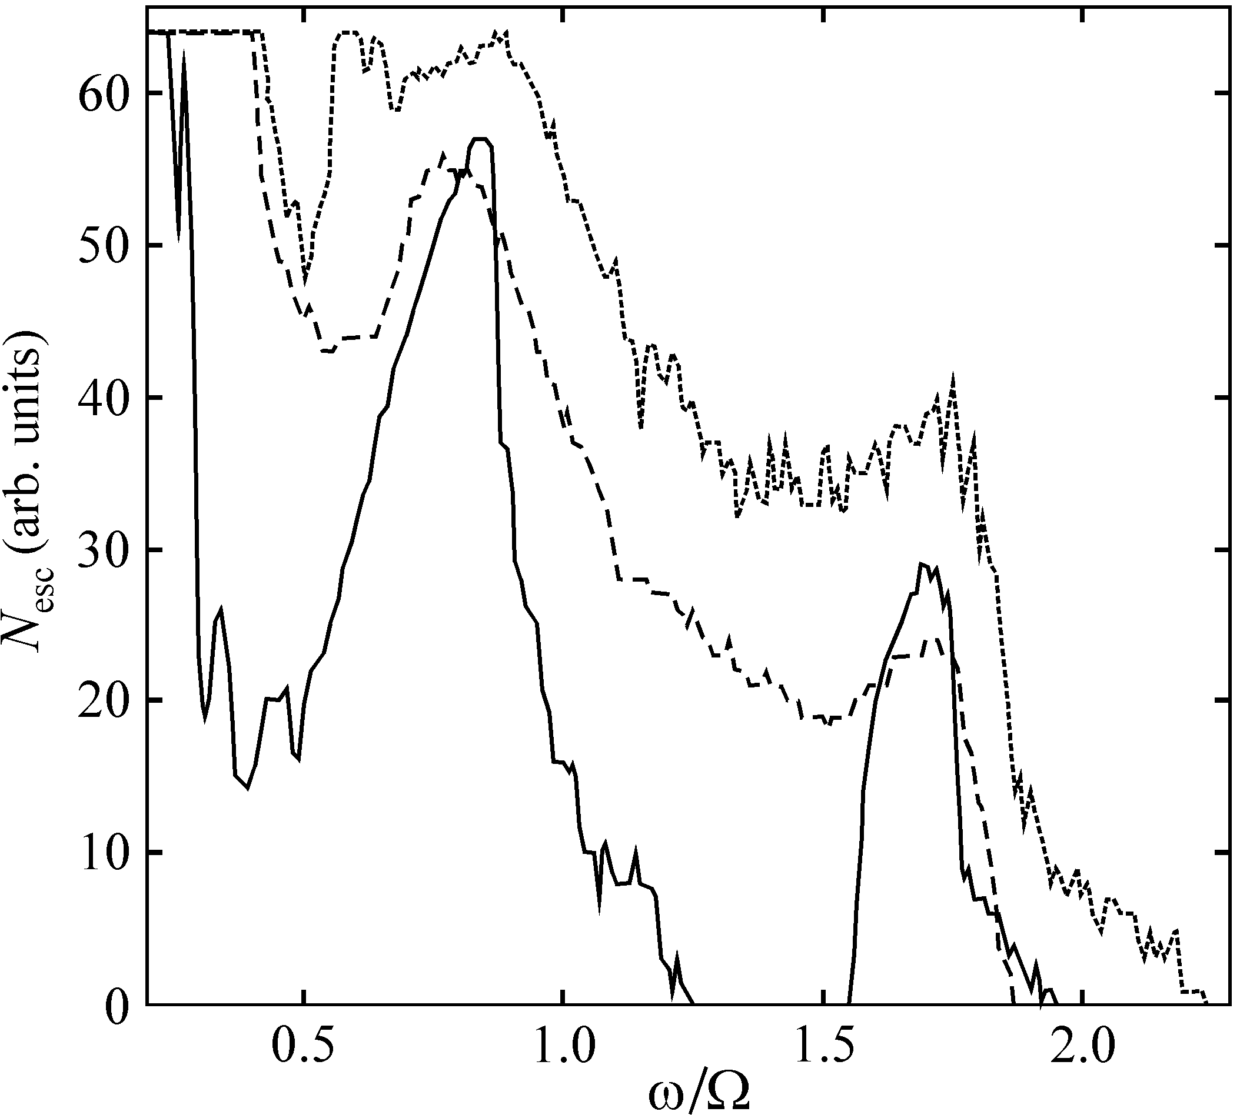
One of the most interesting results in the study of ultracold plasmas (T_{e} ~ 1÷10 К), created in the magneto-optical traps, are subharmonics of the electron emission under irradiation of such plasma bunches by the electromagnetic waves [1]. These subharmonics were initially interpreted as excitation of the standing Langmuir waves, similar to Tonks–Dattner resonances in the gas-discharge plasmas. However, a further development of this idea encountered severe obstacles. One of them is absence of the appropriate reflecting conditions in the unconfined plasma bunch with smooth density profile. Another, even more important obstacle is inappropriate dependence on the electron temperature: the standing waves caused by the thermal correction in the dispersion relation for Langmuir oscillations should be formed more efficiently with increasing temperature, while the experiments show an opposite tendency.
The aim of the present report is to discuss an alternative mechanism for the formation of subharmonics of the electron emission, which is based on ionization of the secondary Rydberg atoms, formed in the process of cooling and recombination of the expanding plasma. As follows from the results of our numerical simulation, illustrated in figure, the number of escaping Rydberg electrons N_{esc} under a stochastic perturbation of their orbits by the external electric field has a few peaks as function of the ratio of frequency of the applied field ω to the Keplerian frequency Ω of the unperturbed electron, which are in qualitative agreement with experimental observations. (Three curves in the figure correspond to various amplitudes and duration of the external field pulses.)
One more argument in favor of the proposed mechanism are the results of immediate measurements of microwave ionization of Rydberg atoms in the atomic beams [2], where clearly-expressed peaks in the efficiency of the electron escape as function of ω/Ω appear when the ionization threshold of Rydberg atoms is artificially reduced. This is quite similar to the ultracold plasmas, where the ionization threshold is reduced just due to the finite distance between the particles.
References.
- Fletcher R.S., et al., Phys. Rev. Lett., 2006, v.96, p.105003.
- Maeda H., Gallagher T.F., Phys. Rev. Lett., 2004, v.93, p.193002.

