Solar flare X-ray sources and electrodynamical model of solar flare
А.I. Podgorny, *I.M. Podgorny, **N.S. Meshalkina
Lebedev Physical Institute RAS, Moscow, Russia, podgorny@fian.fiandns.mipt.ru
*Institute for Astronomy RAS, Moscow, Russia, podgorny@inasan.ru
**Institute for Solar-Terrestrial Physics SO RAS, Irkutsk, Russia, nata@iszf.irk.ru
Flare energy release, which take place in the solar corona, is explained by current sheet occurrence in the vicinity of a singular line of the magnetic field. For MHD simulation of pre-flare situation in the solar corona over a real active region, it is necessary to set all conditions from measurements in the pre-flare state. Performed MHD simulation for the active region AR 10365 in the reduced time scale has shown formation of several current sheets. MHD simulation in real time during a short interval of time has shown the beginning of current sheet creation in the vicinity of the X-type singular line. The program of fast construction of magnetic field configurations in the planes parallel to the chosen plane is created. Lines of equal current density and magnetic lines in the planes parallel to the central plane of computational domain (see the figure above and below at the left) are constructed. For finding-out of an arrangement of a singular line in three-dimensional space, 3D magnetic lines are drawn from points of the current density maxima in two planes, providing guidance on position of this singular line in space (see the figure below on the right). The graphical system is developed, which is necessary for search of the locations of current sheets and places of crossing of photosphere with the magnetic lines which are crossing the current sheet. According to the solar flare electrodynamical model, these locations are positions of sources of X-ray radiation. This hypothesis is necessary for checking up by comparison of results of MHD simulation of possible locations of X-ray emission found from the graphic analysis with positions of sources of the X-ray emission, received by observations.
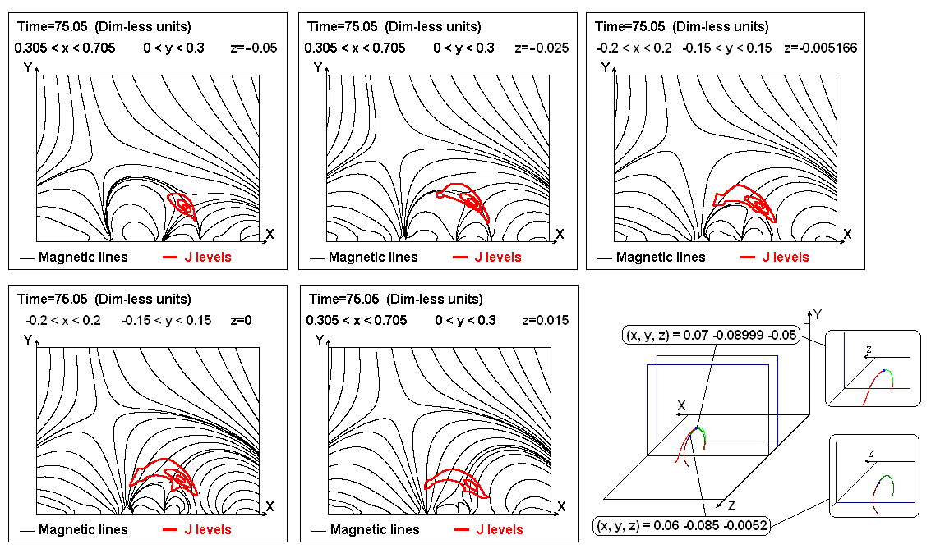
The magnetic field configuration in the active region in the time moment t=7 min.

