On the specific features of temperature evolution in ultracold plasma
Yu.V. Dumin
N.V. Pushkov Institute of Terrestrial Magnetism, Ionosphere, and Radio Wave Propagation, Russian Academy of Sciences, Troitsk, Moscow reg., Russia, e-mail: dumin@yahoo.com
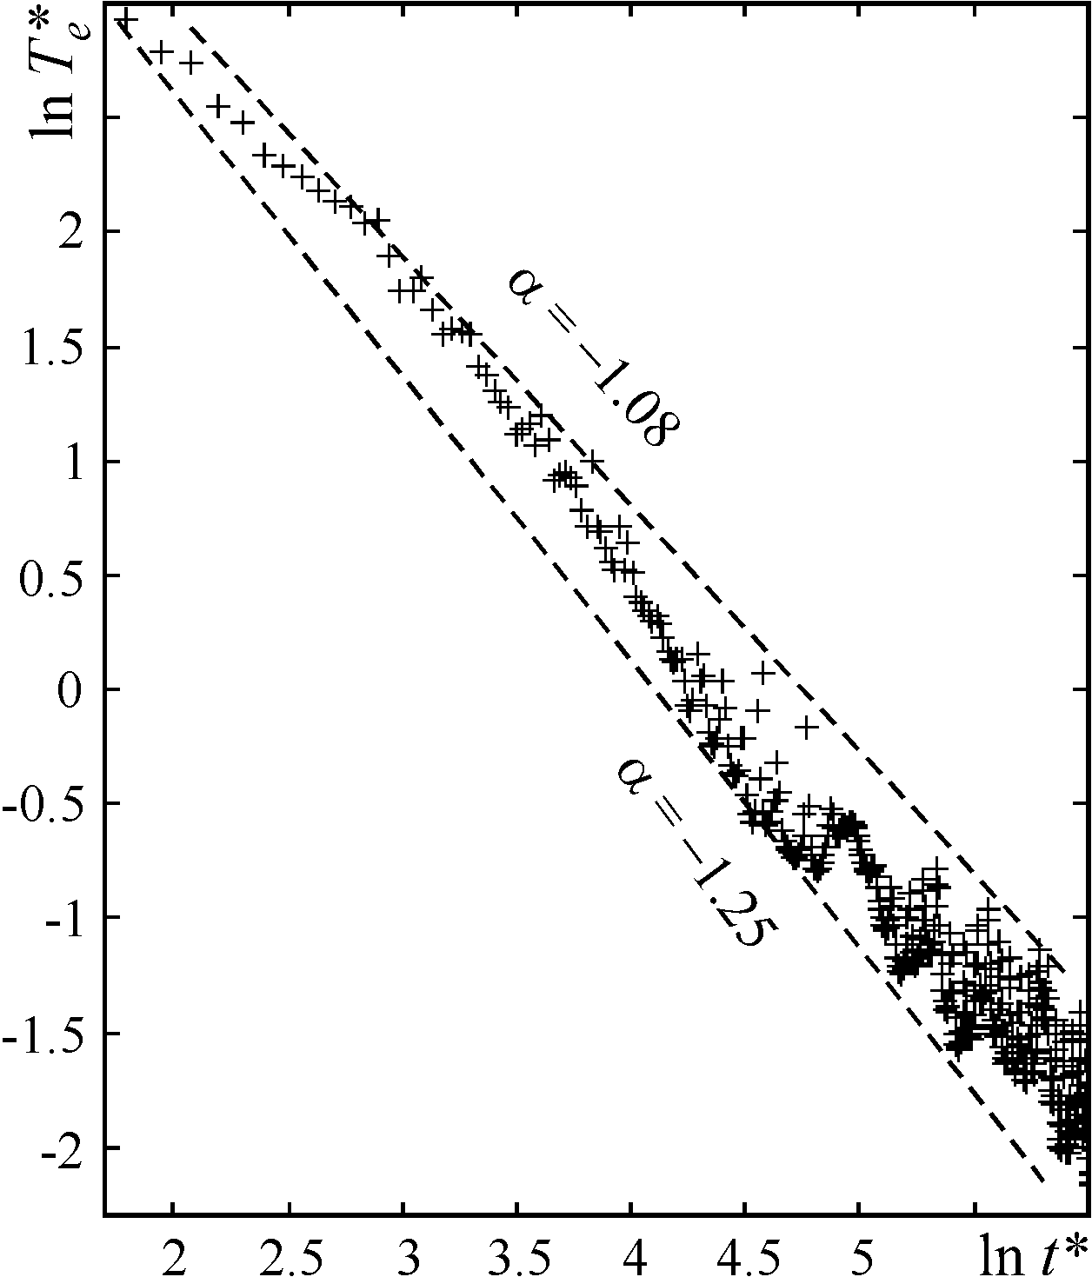
One of the most interesting results of the recent experimental investigations of ultracold (~1÷10 К) rarefied plasmas was a temporal dependence of the electron temperature T_{e} in the plasma bunches released from the magneto-optical trap and expanding freely in space [1]. Contrary to the intuitively expected asymptotic decay by the power law T_{e} ∝ t ^{α} with exponent α = –2, corresponding to the ideal gas without internal degrees of freedom during inertial expansion, the measured exponent was found to be in the range –1.1 to –1.3. The most evident explanation of such slow decay of T_{e} is to take into account the heat release caused by the recombination between electrons and ions. Unfortunately, a number of recent attempts of quantitative modelling of the observed temperature variation due to the above-mentioned effect failed to give a reasonable agreement with the experiments.
The aim of our report is to present the results of numerical simulation by using the specially developed method of “scalable grids”, which enabled us to describe accurately the dynamics of a rapidly expanding plasma bunch with a considerable variation in its spatial dimensions. As follows from the calculations illustrated in figure, the substantially decelerated decay of the temperature can be well explained by the specific features in the dynamics of ultracold plasma with strong Coulomb correlations, while the effects of the heat release due to inelastic processes (in particular, the three-body recombination) are insignificant in the first approximation. The exponent α derived from our simulation over a long time interval is in the range –1.08 to –1.25, which is in perfect agreement with the measurements. It is important to mention also that this effect is not related to the “virialization” of the charged particle energies in the regime of strong Coulomb interactions, which was considered in our early papers [2].
In addition, the simulation method used here enabled us, starting from the “first principles”, to observe formation of the quasi-bound electron-ion pairs (i.e., in fact, recombination of the charged particles into atomic Rydberg states).
References.
- Fletcher R.S., et al., Phys. Rev. Lett., 2007, v.99, p.145001.
- Dumin Yu.V., J. Low Temp. Phys., 2000, v.119, p.377.

