CANONICAL PROFILES AND TRANSPORT MODEL FOR TOROIDAL PLASMA ROTATION IN TOKAMAKS
Yu.N. Dnestrovskij, A.V. Danilov, A.Yu. Dnestrovskij, S.E. Lysenko, S.V. Cherkasov, I.A. Voitsekhovich*
RRC ‘Kurchatov Institute’, Moscow, Russia, e-mail: dnyn@nfi.kiae.ru
*JET-EFDA, Culham Science Centre, Abingdon, OX14 3DB, United Kingdom
A strong toroidal plasma rotation appears during a neutral beam injection. The rotation can considerably affects the plasma, therefore the rotation is intensively investigated both experimentally and theoretically. In the presented report we describe the canonical profiles transport model, which previously included the transport of electron and ion temperatures, plasma density and poloidal field. The extended model also includes the transport of toroidal momentum driven by the external torque. At first we derive the simplest equilibrium equation for rotating plasma. Then we solve the variation problem to find the minimal total plasma energy with condition that the toroidal current is conserved. The Euler equations for this problem define the canonical profiles of pressure p_{c}(ρ) and angular frequency ω_{c}(ρ), linked as ω_{c} ~ p_{c}^{1/3}. The set of transport equations is amended by the equation for the angular momentum n m_{i} R² ω, which includes the radial flux
q_{ω} = −n m_{i} R² χ_{ω}^{PC} ω (ω′/ω−ω_{c}′/ω_{c}).
The term in brackets shows the deviation of the relative gradient of rotation frequency from the canonical one, R is the major radius, n is the plasma density (in 10¹⁹ m⁻³), m_{i} is the ionic mass. The stiffness (diffusivity) of the rotation profile χ_{ω}^{PC} is assumed to be proportional to the stiffness of the electron temperature profile χ_{e}^{PC}: χ_{ω}^{PC} = С_{ω} χ_{e}^{PC}. The value of χ_{e}^{PC} was defined in our previous works, and the constant С_{ω} is found by the comparison of rotation calculations with experimental results for 10 JET shots, which contain the ITER database: C_{ω} = 0.5 / n^{1/3}.
The left figure shows the calculated and experimental profiles of the rotation frequency for the JET shot #60933. The right figure shows RMS deviations of calculated profiles for the rotation frequency d₂ω, density d₂n, electron d₂T_{e} and ion temperature d₂T_{i} from experimental ones. The momentum confinement time is about the energy confinement time, and their ratio τ_{ω}/τ_{E} rises with the density.
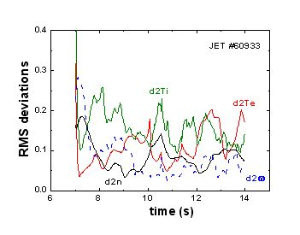
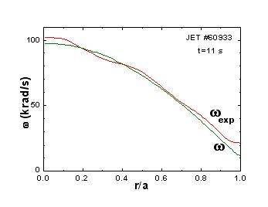
The work is supported by Grants: RFBR 08-07-00182, FASI 02.740.11.5062 and UKAEA 3000132057.

