THE PULSE-PERIODIC HIGH-VOLTAGE DISCHARGE IN ETHYL SPIRIT. ELECTRICAL AND SPECTRAL CHARACTERISTICS, FORMATION OF NANO-SIZED CARBON PARTICLES.
A.M. Anpilov, E.M. Barkhudarov, V.V. Voronov, I.A. Kossyi, M.A. Misakyan, M.I. Taktakishvili
Prokhorov General Physics Institute, Russian Academy of Sciences, Moscow, Russia,
e-mail: kossyi@fpl.gpi.ru
The first results from the investigation of pulse - periodic discharge in spirit are presented which are aimed at finding-out the possibility of nano-sized carbon particles formation. The multispark discharge in a liquid with gas injection in interelectrode space was used as the discharger. Experimental setup is the same as described in [ 1 ].
Power supply parameters were: U ≤ 20kV, storage capacity C=1 -2.10⁻⁸ F. Current pulse duration was equal to τ=3-5μs. Repetition rate was f=50Hz. Experiments were carried out using 95 % ethyl spirit. Argon was used as injected gas. The discharge proceeded in bubbles of argon filled with spirit saturated vapor. The electrical discharge parameters in distilled water and spirit were practically similar. The electron density n_{e}=2-3.10¹⁷ cm⁻³ was determined from the profiles of hydrogen spectral lines broadened due to the Stark effect in plasma electric field. After processing by the discharge, spirit became dark-colored, and at the expositions τ ≥ 5min it became almost black. The sedimentation did not occur during nearly month observation.
Spectra of combination scattering were detected using the spectrometer I-1000 operating in the mode of micro samples research having the resolution of 5nm⁻¹. Exciting radiation wavelengths were λ =488nm and 647 nm. The spectra of the black film on a glass substrate and the evaporated drop on a silicon substrate are identical and correspond to the spectra of disordered carbon in the form of graphite nanoparticles.
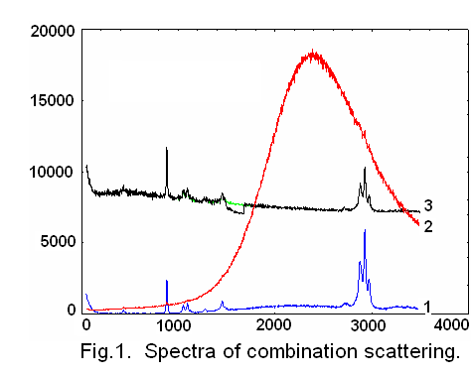
The combination scattering spectra of solutions are shown in Fig. 1. (1) is for the spectrum of initial spirit. There are many impurities in it which give a wide luminescence band in the spectral area 1000 – 3500cm⁻¹. Presence of the impurities and carbon nanoparticles in the solution leads to the occurrence of a strong luminescence band (2). Spectra (1) and (2) were registered at exciting radiation wavelength of λ =488nm.
As the exciting wavelength was changed to λ =647.1 nm, the luminescence band disappears (3). The research results allow concluding that carbon nanoparticles of 1-10nm size are present in a dark solution and contain atoms with sp² and sp³ links.
The X-ray structure analysis indicates the presence of different carbon structures with particle dimensions of about several nanometers. We identified the chemical composition of the powder obtained by evaporating the treated spirit: С – 79.05%, О – 19.57%, other is Si, K, Ti, Cr, Fe.
References
- A.M. Anpilov, E.M. Barkhudarov, Yu.B. Bark et all, J. Phys. D: Appl. Phys., 34, 993, (2001).

