3D modeling of microwave electrode discharge in hydrogen
Yu.A. Lebedev, A.V. Tatarinov, I.L. Epstein
A.V. Topchiev Institute of Petrochemical Synthesis, RAS, Moscow, Russia, atat@ips.ac.ru
We present the simulation results of 3D modeling of microwave hydrogen discharge, which appears in the vicinity of central electrode, along which the electromagnetic energy enters the chamber, when the size of the plasma chamber is bigger than the size of a plasma formation [1]. Ball-shaped plasma sustained at the tip of the central cylindrical electrode is observed in experiments with hydrogen, nitrogen and other gases in the range of pressures 0.5-15 Torr.
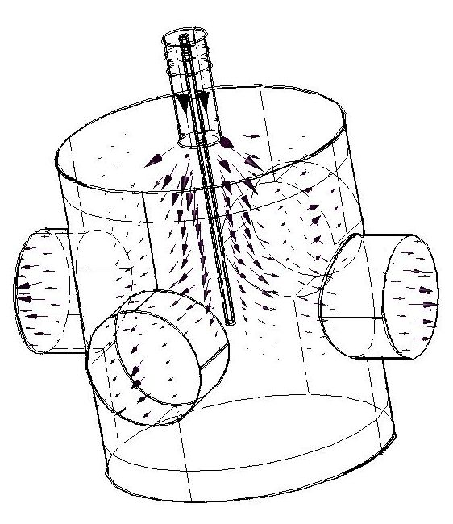
Kinetic model for the hydrogen plasma includes balance equations for charged (e, H-, H+, H2+, H3+, H5+) and neutral (H, H(2S, 2P), H(3S, 3P, 3D)) particles (the scheme consists of 27 reactions [2]). The processes of direct electron impact ionization, step and associative ionization are considered. The reaction rate coefficients for processes with free electrons are found by means of the electron energy distribution, calculated from homogeneous Boltzmann equation for electrons obtained in the two-term approximation. The microwave fields are calculated from the Maxwell equations. The static electric field which appears due to local disturbance of quasi-neutrality results from the Poisson equation. The system of equations are solved using a COMSOL Multiphysics package.
Spatial configurations of microwave fields inside an empty chamber, fully equivalent to the experimental one, have been obtained for different distances of the central electrode from the bottom of the chamber. The positions of the central electrode for which the energy of dissipation through the watch windows has its minimal value have been determined (a power flux inside the chamber is shown with arrows). Optimal length of the central electrode was found very close to the one, obtained in experiment. It is shown that due to the presence of the watch windows the hydrogen discharge can exist only when the central electrode is positioned in the vicinity of those optimal lengths. In the absence of watch windows the discharge exists at any length of the central electrode. The dependence of matching between the discharge chamber and feeder on the system parameters has been analyzed. An analysis of spatial distributions of all discharge species have been carried out. The results of simulations are found in qualitative agreement with experiments. It is shown that 3D modeling allows considering important details of chamber construction, which a 2D model cannot describe, and hence allows improving the forecast features of the developed model.
This study was partly supported by the RFBR Grant 07-08-00020-a.
References
[1]. Lebedev Yu.A., Mokeev M.V., Tatarinov A.V., Shakhatov V.A., Epstein I.L. J. Phys D : Appl. Phys, 2008, 41, 194001.
[2]. Lebedev Yu.A., Epstein I.L. J. Moscow Phys. Soc., 1995, 5, 103-120.

