TWO MODES OF UNIPOLAR GAS BREAKDOWN DISCHARGE
A.K. Sukhov, T.P. Kopeikina
The Kostroma state university, Kostroma, Russia, e–mail: suhov_andrei@mail.ru
Two modes of existence of the unipolar gas breakdown discharge [1,2], depending on movement frequency of high-voltage impulses applied are experimentally established.
At low frequency of positive polarity impulse movement high-current mode of unipolar gas breakdown discharge burning, which in the whole investigated range of impulse amplitude is characterized by small sizes of discharge luminescence area, linear volt-ampere characteristic with sensibly constant resistance of discharge column and low concentration of the charged particles in plasma, is observed.
At the high movement frequency of positive polarity impulses and in the whole range of frequencies for impulses of negative polarity the low-current mode of burning of unipolar gas breakdown discharge, characterized by greater length and intensity of luminescence area radiation, nonlinear volt-ampere characteristic and higher concentration of the charged particles in plasma is observed.
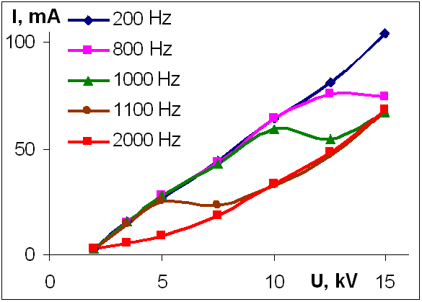
The measured volt-ampere characteristics of discharge are shown on the diagram. At low impulse movement frequency (200 Hz) the volt-ampere characteristic is linear, at higher (2000 Hz) is nonlinear. At intermediate values of frequency the volt-ampere characteristics have intermediate character.

The transition from one form of the discharge to another for positive polarity impulses occurs in a narrow range of frequencies sharply enough. The frequency of transition grows with the increase in gas pressure and the reduction of impulse amplitude. In the transition area the development of discharge instability with frequency of about 1 Hz, which appears in the form of periodic change in length of a discharge column and nonmonotonic distribution of luminescence intensity on its length, is observed. At the increasement and at the reduction of impulse movement frequency the hysteresis of discharge column length is found.
References
- Gerasimov I.V. Emissive properties of unipolar gas breakdown discharge // Journal of technical physics. (Russia) – 1994. – V. 65. – PP. 30–35.
- Gerasimov I.V. About propagation of unipolar electrodeless gas breakdown // Plasma physics. (Russia) – 1988. – V. 14. – PP. 1240–1247.

