Solitons in two-fluid MHD with non-zero electron inertia
M.B. Gavrikov, V.V. Savelyev, A.A. Tayurskiy
Keldysh Institute of Applied Mathematics RAS, Moscow, Russia, ssvvvv@rambler.ru
The results of analytical and numerical investigation of solitary waves on the basis of two-fluid MHD with non-zero electron inertia for cold plasma are presented in the report. Nonlinear waves with linear polarization of a magnetic and electric fields are considered.
(1)
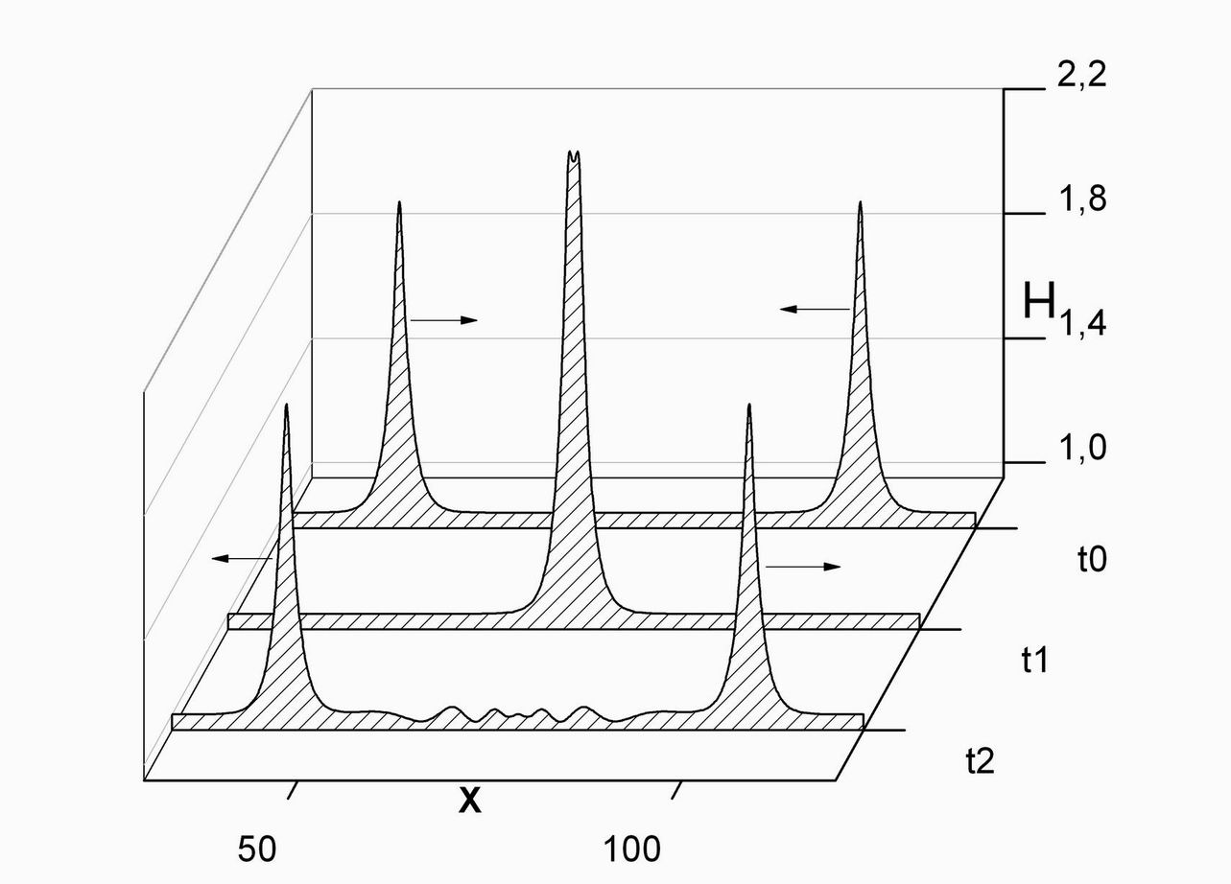
Non-zero mass of electron and respectively nonlocal Ohm’s law are the reason for wave dispersion. This effect is especially important for short waves then. A main difference of the present work is the using of the "exact" equations (1), instead of the modeling equations. The phase velocity of solitary wave has to satisfy with condition and its amplitude is proportional to phase velocity -. It is numerically shown, that solitary waves are solitons really, i.e. their interaction is similar to interaction of colliding particles. On figure it is shown as an example the process of «collision» of two solitons with equal amplitudes and opposite signs of phase velocity.

