ABOUT THE POSSIBILITY OF REAL-TIME SIMULATION OF SOLAR FLARE ENERGY ACCUMULATION.
A.I. Podgorny, *I.M. Podgorny
Lebedev Physical Institute RAS, Moscow, Russia podgorny@fian.fiandns.mipt.ru,
*Institute for Astronomy RAS, Moscow, Russia, podgorny@inasan.ru
Primordial flare energy release observed high in solar corona, where the energy accumulation can occur only in the magnetic field, is explained by current sheet appearance in the vicinity of a singular line. During the quasi-stationary evolution the current sheet transfers in unstable state causing explosive energy release. For simulation of the preflare situation in the solar corona above a real active region it is necessary to set all initial-boundary conditions for MHD equations from observations. The calculations are initiated several days before the flare when the strong disturbances are absent in the corona. So the potential magnetic field calculated from observed field distribution on the photosphere is used for setting of initial conditions. In previous MHD simulations the magnetic field on the photosphere has been changed in 10⁴ – 10⁵ times faster than in the reality. This causes strong disturbances with large currents, which can mask current sheets. Also the appeared unrealistically large velocities can displace current sheets positions comparing with real ones. To perform MHD simulation of active region evolution in the real time it is necessary to accelerate calculations strongly. It can be reached by improving of mathematical methods, so that the finite-difference scheme is remained to be stable for sufficient big time steps. For this purpose the diffusion term approximation that earlier used in the absolutely finite-difference scheme is modernized. The scheme is conservative relative to the magnetic flux. The finite-difference scheme becomes more stable, if the error of the initial magnetic field divergence is sufficiently small. To decrease this error the method of Laplace equation solving for initial potential field definition is improved. Then two corrections of the potential field are performed to minimize the magnetic field divergence. First of them is realized by solving of the diffusion equation for the magnetic field, the second one consists in adding the field of charges inserted in the centers of cells of the difference scheme grid. In spite of application of modernized methods the calculations are performed rather slowly so that one day of active region evolution is calculated on usual personal computer during ~ 1 year. The estimations of calculations acceleration using supercomputers, which is necessary to apply the MHD simulation for improving the solar flare prognosis, are done. In that case simulation of active region evolution during the time period significantly less then one day is performed. The beginning of current sheet creation by focusing of disturbances in the vicinity of an X-type singular line is demonstrated. For convenient definition of the flare emission sources positions and representation of magnetic field and plasma flow configurations near them the graphic visualization method with simultaneously calculations is partially modernized. The results are presented in the 2D and 3D space in the appropriate coordinate system. The magnetic field and plasma behavior near places, where current sheet creation should occur, are shown (see Figure).
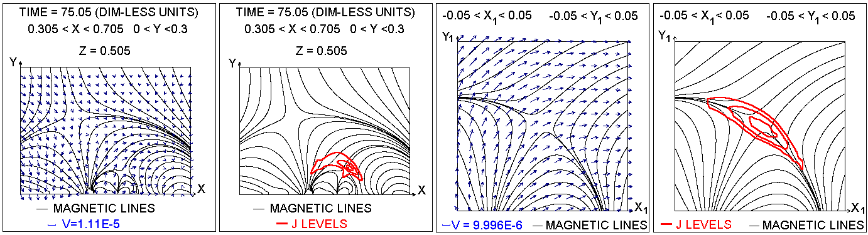
Figure. Magnetic field, current density and velocity in the vicinity of singular line.

