BALL LIGHTNING GENERATION AT «PROMETEUS-2" INSTALLATION
Oreshko A.G.
Moscow Aviation Institute, Moscow, Russia, Oreshko_Alex@mail.ru
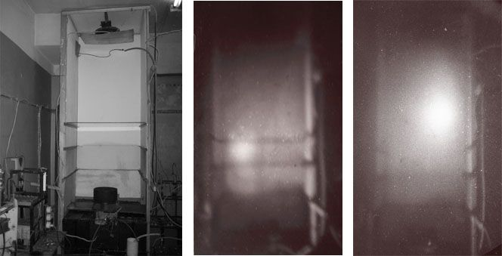
A ball lightning as a plasma system with magnetic field induction minimum in the center of its kernel is of an extreme interest for nuclear fusion. In a ball lightning generation area the intensive flows of fast ions can be obtained, the energy of which is sufficient to overcome Coulomb’s potential barrier [1]. The prior experiments made at “Prometeus” installation showed that a ball lightning generated at the initial pulse stage [2]. To increase energy transfer efficiency from capacity storage to a ball lightning on the basis of “Prometeus” installation a “Prometeus-2” installation was built. The storage parameters of a new installation are: charge - 0.4 Coulomb, charge voltage – 50 kV, stored energy – 10 kJ. The current in a discharge cell was equal 140 kA and a pulse duration was about 100 microseconds. In the course of experiments the following parameters were measured: voltage and current in a discharge cell, ball lightning potential by means of a probe and a divider, the collector current at ball lightning collapse. Microwave radiation in a discharge and bremsstrahlung generated were registered while a ball lightning was passing through absorbers. Ball lightning luminescence was registered optically by means of optoelectronic converters. It was discovered that a ball lightning passes not only through glass but also through plastic and metal sheets as well as a water layer 18 cm deep. During experiments on ball lightning passage through very thick absorbers a dark spherical area was visually observed. A diameter of that area and the time of its appearance approximately agreed with a diameter and the time of ball lightning appearance with no absorber present. Perhaps, a dark spherical area consists of fundamental elementary particles of the Universe. General view of field for experiments and images of ball lightning for two interval of time are given on next figures.
References
- Oreshko A.G. “Possibility ball lightning application for nuclear fusion”. Programm 35th Europen Physical Society Conference on Plasma Physics. Hersonissos, Crete, Greece, 9-13 June, 2008. Report D5.005.
- Oreshko A.G. “Research of a ball lightning and prospects of it’s use for applied purposes”-VI Intern. Conf. Plasma Physics and Plasma Technology. Contributed papers. Vol.I. Minsk, Belarus, September 28 - October 2, 2009, p.137-140.(PPPT-VI).

