NONSELFMAINTAINED DISCHARGE FOR PLASMA IMPACT ON PROPANE- AIR MIXTIURE
*Ardelyan N.V., Bychkov V.L., Bychkov D.V., Denisiuk S.V., Gudovich V.A., **Kochetov I.V., *Kosmachevskii K.V.
Federal state unitary Enterprise “Moscow Radiotechnical Institute RAS” Moscow, Russia,
bychvl@orc.ru
*Moscow State University, Moscow, Russia,
**TRINITI, Troitsk, M.reg., Russia
We have created an experimental installation on a basis of electron accelerator with main parameters: electron-beam energy Е_{b}= 200-400 keV, electron – beam current from 1 to 20 mА. A diameter of moving ionization section is 2 cm. A frequency of a longitudinal scanning is 300 Hz, a frequency of a transversal scanning is 5 kHz. A size of an outlet window is 100 х 5 сm. In Fig.1 one can see a functioning scheme of the installation. Accelerated electron beam goes through a drift chamber, an outlet device and out let window, and then it appears in the atmosphere. Here it can be used for radiation impact on an object. The installation is aimed for impact on propane-air mixture.

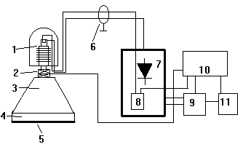
Fig.1. Functioning scheme of the installation: 1- accelerating tube with thermal cathode, 2-beam –scan device, 3- beam-drift chamber, 4- beam outlet device, 5-outlet window, 6- high voltage cable, 7- high voltage rectifier, 8- thermal cathode channel feeding device, 9- voltage regulator, 10- control system, 11- power supply system.

We have fulfilled calculations of parameters of selfmaintained (on a basis of Boltzmann equation solution) non-selfmaintained discharges and electron-beam plasmas in stoichiometric propane-air mixture. In calculation plasma chemical scheme we applied we accounted 119 chemical reactions in air and 74 reactions in propane (Varatharajan B., Williams F.A. 2002). Obtained results on autoignition are well fit to experimental data. We have obtained times of ignition at different initial temperature of the mixture.
