Creation of crystals with discharge in supersonic air stream with solt water drops
*Biturin V.A., **Bikov A.A., Velikodny V.U., Krichenko O.V., Popov V.V., Pogorelova L.V., Samuolis I.A.
Institute of applied mechanics of RAS, Moscow, Russia, e-mail: dolgonosoki@gmail.com
*Union institute of hight temperature of RAS, Moscow, Russia.
**Moscow institute of physics and technology, Moscow, Russia,
e-mail: Aleks-Bykov@yandex.ru
Authors investigated influence of the plasma formations received in the erosive discharge in a supersonic stream of microdrops of electrolit NaCl + H2O on a dielectric substrate (laboratory glass), located on the spending screen earthed on the case of installation. Detail design and a principle of work of installation was reported by us earlier [1]. The microscopic analysis revealed that there ara crystals of the various form and sizes(10-100 mkm) on the glass. They has pyramidal and pentax forms, also there is a quantity of threadlike formations. At electrolit sedimentation on a surface of a substrate without the category crystals characteristic for NaCl the cubic form turned out. On fig. 1 crystals pyramidal forms and result of their scanning on microscope ZYGO with increase 4000 are shown. It is visible that the crystal has the form of a concave pyramid that is uncharacteristic for salt crystals in the centre. Also on fig. 2 are shown pentax crystals which also are uncharacteristic for salt. We will in addition note presence of the melted off keen edges of crystals with pentax form. Researches of crystals of the "abnormal" form on an electronic microscope has shown that they consist Na and Cl.
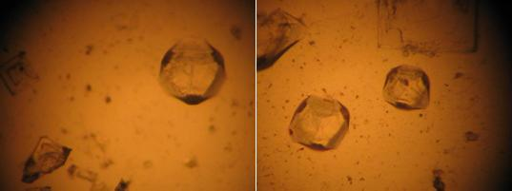
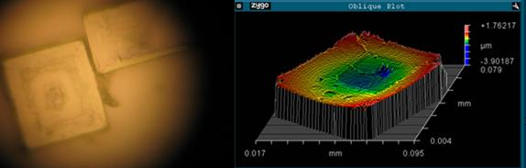
Pic. 1
Pic.2

