high-durability DC arc plasmatron
Piskunkov A.F., Riaby V.A., Svotina V.V., *Lee H.-J., *Plaksin V.Yu.
State Research Institute of Applied Mechanics and Electrodynamics – Moscow, Russia,
e-mail: riame@sokol.ru
*Cheju National University, Cheju, Resp. Korea, e-mail: hjlee@cheju.ac.kr
Recently a new high-durability DC arc plasmatron has been developed. It belongs to a traditional type of arc plasma sources with a “hot” rod cathode (tungsten) and a “cold” nozzle anode (copper) where an inert gas like argon is supplied to protect the tungsten cathode. This report sums up previously published materials where different aspects of this development were presented.
The durability of a conventional plasmatron of this type is limited with an anode so its erosion should be decreased to raise the service life of the whole device. This task can be solved if the location of the arc spot is fixed and the surface of the spot is enlarged. In the present work the anode spot was fixed creating a whirl disturbance on the anode surface, which is a well-known method. But this disturbance had to be arranged in a special way to lower the anode spot current density. This special way was found out luckily using T-form of the plasmatron gas-flow path in which anode channel was connected to the middle of the wide wall of the flat technologic channel. Technologic gas was supplied through this channel interacting with the argon plasma cross flow creating some whirl zone. Due to the form of the plasmatron flow path it was named T-plasmatron. The fact of the low anode spot current density realization has been proved in special experiments while measuring the anode specific erosion rate: m_{A}=3.6⋅10⁻¹⁰ g/C. This parameter turned out to be nearly 5 orders of magnitude lower as compared to the traditional level. The ability of the T-plasmatron to activate technologic gas was checked in the processes of Diesel fuel reformation into the synthesis gas and thin film etching/deposition giving satisfactory results.
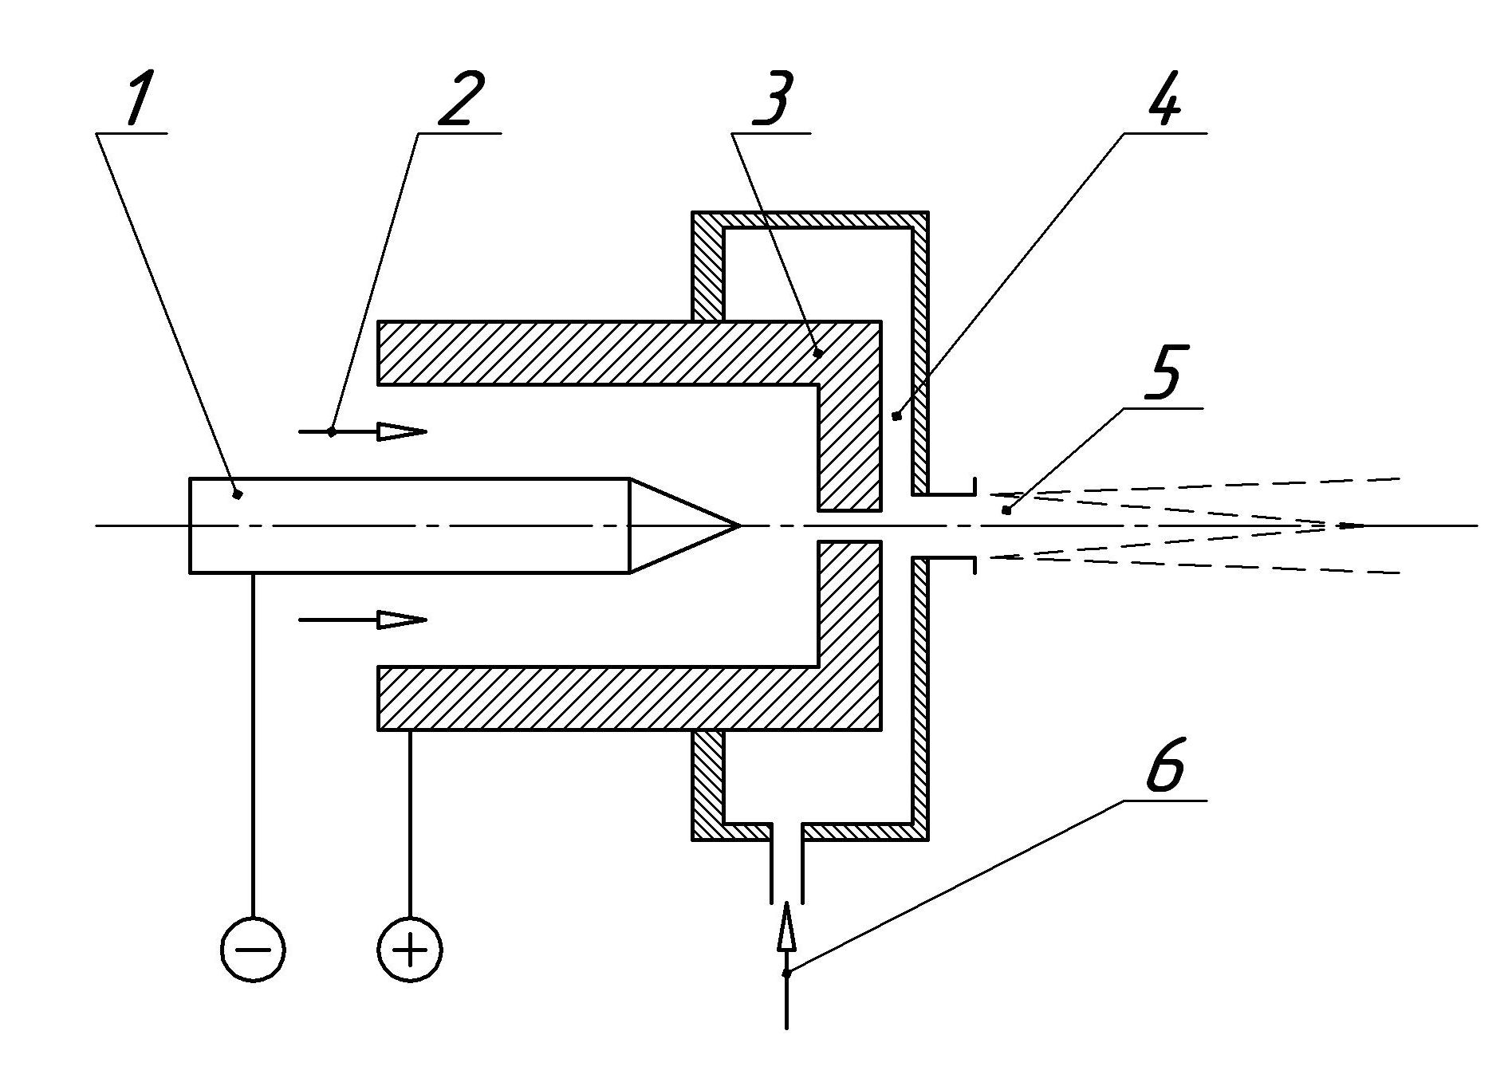
In the frames of the subsequent investigations the flat technologic channel of the T-plasmatron was re-formed into a flat circular slot supplying technologic gas into the argon plasma flow at the exit of the anode channel. This design of the plasmatron cross-flow lay-out allowed us to continue the success of the T-plasmatron giving nearly the same level of the anode specific erosion rate m_{A}~10⁻¹⁰ g/C. This fact confirmed the distributed character of the anode spot for the A-plasmatron. Contrary to the previous plasmatron model, plasma-chemical experiments showed that this plasmatron model can activate reactive gas species 3 times
Schematic diagram of the A-plasmatron is presented in the figure. Here 1,3 are electrodes, 2- argon supply, 4- technologic channel, 5- running out product flow, 6- technologic gas supply.
So for the new plasmatron its catho-de limits durability of this plasma source (m_{C}~5⋅10⁻⁹ g/C): at arc current 50 A plasmatron service life can reach
~1000 h
(in this situation tungsten cathode of 3.2 mm in diameter will become shortened by ~6 mm elongating the arc according-ly which can be quite acceptable).

