parameters of PLASMA confined in the decreasing-field configurations with various plasma anisotropy
M.M. Tsventoukh
P.N. Lebedev Physical institute RAS, Dept. of Phys. Electronics, elley@list.ru,
Moscow engineering and physics institute (State university), Plas. Phys. Dept.
Plasma pressure distributions that are stable to the interchange modes (in configurations without minB) due to plasma compressibility effect are considered in the collisionless kinetic description [1]. It is necessary when the plasma component that produces most of plasma pressure have rare collisions, as e.g. in ECR experiments [2].
As it is known, in the kinetic description the more anisotropic plasma distributions (where magnetic mirrors contain a less plasma) have the more sufficient plasma pressure gradients than the isotropic ones [3]. In this work the influence of the anisotropy function distribution on results of convective-stable profiles calculation is considered. At the picture calculated profiles of the plasma pressure (for an equatorial plane of a mirror-device with a divertor) p(ψ) and the energy function $ε(ψ)=p(ψ)\int{[G(B,ψ)/B]\text{dl}}$ (where 0≤G(B,ψ)≤1 – the anisotropy function; an integration along the field line) are drawn for three cases. At 1 – plasma is isotropic G₁=1, at 2 – the anisotropy G₂ monotonically changes from the isotropic distribution at the separatrix to the anisotropic peak of pressure at the axis (namely at the axial field minimum), at 3, on contrary, the anisotropy G₃ changes monotonically from the isotropic distribution at the axis to the pressure peak at the separatrix. These are a contrast cases: the G₂ distribution gives the biggest and the G₃ – the lowest pressure ratio from the core to the perifery p(0)/p_{perif}. Whereas, as follows from dependencies ε(ψ), the distribution 3 (with an isotropic center and peak near separatrix) is better than 2, as a bigger energy stored in the trap.
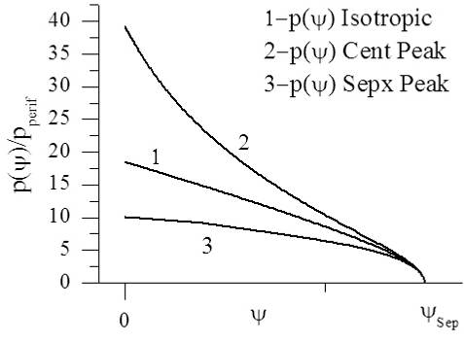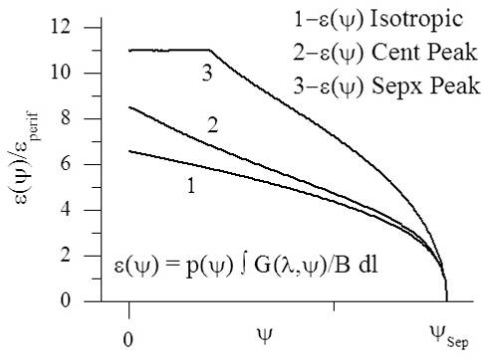
The G₂ distribution with pressure peak at the axis can be applied in a single mirror device with big peak-energy storing in the center of a trap. The G₃ distribution with the isotopic center and the peak at the separatrix can be applied in (closed) mirror-device chains, with the less energy at the periphery (what can be needed e.g. for the high-beta regimes).
References
- B.B. Kadomtsev, in Plasma Physics and the Problem of Controlled Thermonuclear Reactions, ed. M.A. Leontovich, AS USSR 4 370 (1958) (Pergamon Press, New York, 1961); M.D. Kruskal, C.R. Oberman, Phys. Fluids 1 275 (1958).
- D.T. Garnier et al, Phys. Plasmas 13, 056111 (2006); G.V. Krashevskaya, V.A. Kurnaev, M.M. Tsventoukh, Proc. of 28th ICPIG, July 15-20, 2007, Prague, Czech Rep., P. 393.
- V.V. Arsenin, A.Yu. Kuyanov, Fiz. Plasmy 27 675 (2001) [Plas. Phys. Rep. 27 (2001)]

