Propagation of microwave subcritical streamer discharge against radiation by brunching and looping
Kirill V. Khodataev
UFSE “Moscow Radiotechnical Institute of RAS”, Russia, K.V.K@home.ptt.ru
In experiments with initiated undercritical microwave (MW) streamer discharges, executed, as rule, in focus of MW radiation beam, the steady tendency to streamer channels development against radiation limitlessly in frame of MW pulse durance. By numerical modeling on specially designed models it was clearly shown, that the streamers structure self sustains the resonance (electrodynamic) state, which allows continuous appearance of streamer effect, by means of brunching and looping [1,2]. It is naturally to suppose, that propagation against radiation is explained by shielding of radiation field by front part of streamer discharge in space behind it, as it held usually in waveguide at the appearing of MW discharges, running, as known, to generator. But, observations show, the streamers, appeared at initiator, rise against radiation from the very beginning, when factor of MW field shielding cannot play role (see Fig.1). What is defining just bright non symmetry of process?
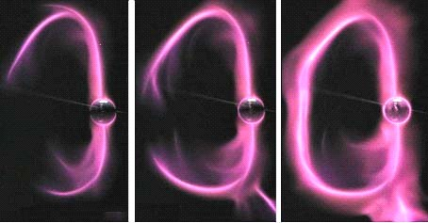
For answer on this question the free propagated streamer model was designed. In Ref.[Error: Reference source not found] the supposition about important role of ministreamer hedgehog at the streamer head. In connection with it, in new model at every time step the hedgehog of ministreamers appears. Directed in side of maximum resulted electric field amplitude ministreamer has a preference development.
Modeling has shown that in field of a flat wave radiation the first streamers, started from initiator, lock itself in a loop in direction of wave propagation. At the same time, if initiator is located in a focus of radiation, the fist streamers surely develop against radiation and locate itself in loop, as it is seen in Fig.1. Note, that though the discharge propagation is assisted by strong UV radiation, the modeling experience shows, that this factor is not determining for its distribution.
Fig.1. Initial stage of streamer discharge development in focus of MW radiation
References
- Kirill V. Khodataev. Investigation of undercritical microwave discharge ability to propagate limitlessly by continuous branching of the streamer. 44th AIAA Aerospace Sciences Meeting 9-12 January 2006, Reno, NV. Paper AIAA-2006-0785
- Kirill V. Khodataev. Factors defining propagation of microwave subcritical streamer discharge against radiation. 7th Workshop on Magneto-Plasma Aerodynamics, March 27-29, 2007, Moscow, Russia

