on existance of spatial charge layers in the plasma resonance region
Yu.A. Lebedev, A.V. Tatarinov, I.L. Epstein
A.V. Topchiev Institute of Petrochemical Synthesis, RAS, Moscow, Russia, atat@ips.ac.ru
We present the simulation results for strongly non-uniform microwave discharge, which reveal the appearance of spatial charge layers in plasma resonance region.
One-dimensional quasi-static model for a stationary microwave nitrogen discharge inside spherically symmetric system of electrodes has been developed [1]. The model consists of the microwave field equation in quasi-static approximation, the Poisson equation, the balance equations which describe the kinetics of charged (e, N₂⁺, N₄⁺) and neutral (N₂(A³∑⁺_{u}), N₂(B³П_{g}), N₂(C³П_{u}), N₂(a’¹∑⁻_{u})) plasma components, time-independent homogeneous Boltzmann equation for electrons obtained in the two-term approximation. The kinetic scheme involves the direct electron impact ionization, step and associative ionization, volume and wall recombination of charged and neutral particles, ion-molecular reactions, excitation and de-excitation processes for molecules. Processes with vibrationally excited molecules are accounted for by using the well-known analytical expression for the vibrational distribution function (VDF) obtained in the diffusion approximation [2].
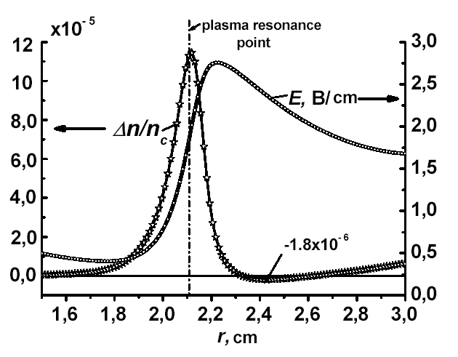
It is shown that a layer of spatial charge appears at the point of plasma resonance distant from the inner electrode. This results in a peak of electrostatic field (Fig.1). Depending on discharge parameters the alternate layers of negative and positive charge can be formed.
This study was partly supported by Program # 9 of Fundamental Research of the Presidium of the Russian Academy of Sciences and the RFBR Grant 07-08-00020.
Fig. 1 Profiles of the spatial charge and electrostatic field in plasma resonance region. Here $Δn=N_{2}^{+}+N_{4}^{+}−n_{e}$, $n_{c}=7×{\text{10}}^{\text{10}}$ cm ⁻³ is the critical electron density. Nitrogen pressure is 1 Torr.

References
- Lebedev Yu A, Epstein I L 2007 Plasma Phys. Rep. 33 1 63
- Gordietz B, Osipov A, Shelepin L 1980 Kinetic processes in gases and molecular lasers, (Moscow Nauka)

