From TM-2 and T-3 to DEMO and farther
(to 50th anniversary of achievement of the first 100eV on TM-2)
S. Mirnov
State Research Center of Russian Federation Troitsk Institute for Innovation and Fusion Research, Troitsk, 142190 Russia
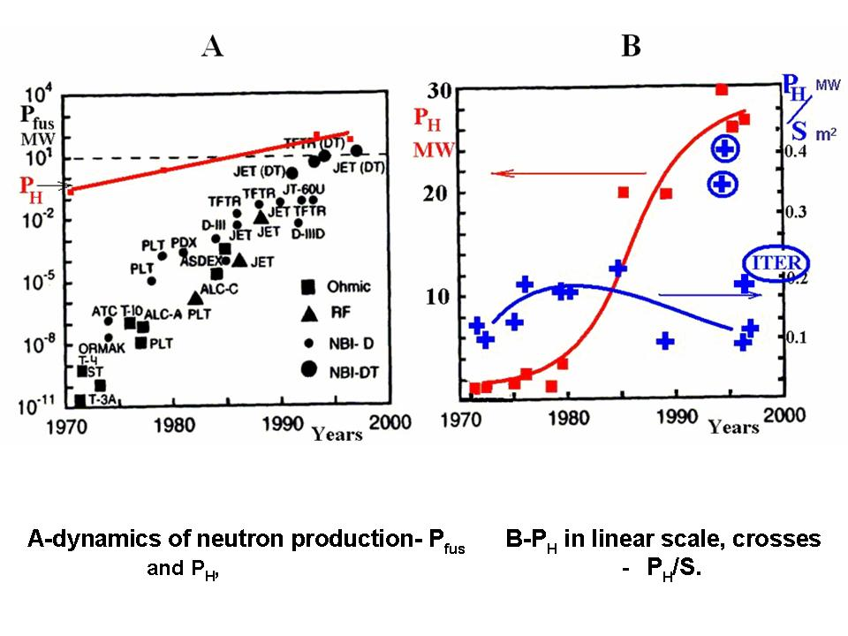
50 years ago the first macroscopic stable tokamak discharge with electron temperature more than 100eV was achieved in Plasma Investigation Division of Kurchatov Institute by E.P.Gorbunov and K.A.Rasumova at the TM-2 tokamak (tokamak small-2). One year past, such operation mode of tokamak was repeated by L.A.Artsimovich et al. at the biggest Russian T-3 tokamak. The following comparison of plasma confinement in these devices permitted (1968Y) to suggest the first phenomenological tokamak τ_{E} scaling τ_{E}~a²H_{φ}, which became the physical basis of creation of numerous tokamaks in world (Fig.A). The progress in this direction leaded to creation of pre-burning tokamaks with DT-fusion production on the level 10MW and start of ITER tokamak-reactor with proposed DT-fusion production on the level 500MW. Such kind tokamaks can be suggested today as the commercial fast neutron sources (FNS) for nuclear power as minority transmutators and breeders of nuclear fuel. The Russian fission community places several heavy demands to quality of fusion neutron source for the first step of technological investigation in these fields. They are: the steady state regime of neutron production (not rare 80% of main operation time), the total power on neutron flux should be not lower than 20MW with surface neutron load not lower than 0.2MW/m². Two well known DT-tokamaks with neutron power production higher 10MW - TFTR and JET- had maximal neutron load approximately 0.1MW/m² only in transient (with time scale lower 1s) regimes. The quasi steady state neutron emission regime (~5MW, 5sec) was performed in JET with mean surface neutron load lower than 0.025MW/m² only. What we should do for transition from current tokamaks to the first step of fusion neutron source? The analysis of numerous experimental results (Fig.B) shows, that most critical parameter for high performance tokamak regimes is the mean first wall heat load, which can be used for estimation of future fusion perspectives. In this communication it will be discussed the main needs of JET scale tokamak improvement for increase on mean neutron load up to 0.2MW/m². They are: decrease of Z_{eff} by ECRH and lithium use as plasma facing components, the increase of energy of steady state neutral injectors up to 150-170keV (tritium), the He removal and creation of closed loop of DT fuel circulation. It will be discussed the perspectives of DEMO and futures steps in fusion.

