CREATION of strong microrelief on titanIUM in microplasma discharges with a current Of 200 And pulse duration of 20 мс
V.A. Ivanov, M.E. Konyzhev, L.I. Kuksenova*, V.G. Lapteva*, M.S. Alekseeva*, A.A. Letunov, A.S. Sakharov, T.I. Kamolova, A.A. Dorofejuk, S.N. Satunin
Prokhorov General Physics Institute, Russian Academy of Sciences (GPI RAS),
Moscow, Russia, ivanov@fpl.gpi.ru
*Blagonravov Institute of Machinery, Russian Academy of Sciences (IMACH RAS),
Moscow, Russia
The interaction of a pulsed flow of hydrigen−carbon plasma (with a density of 10¹³ см⁻³ and pulse duration of 20 μs) in vacuum with a titanium sample covered by a 1-μm-thick dielectric film results in the excitation of microplasma discharges on the sample surface. As a result of microplasma processing of the titanium sample, a 10-μm-thick strengthened layer with a developed microrelief and strongly modified morphological, structural, and tribotechnical properties forms on its surface. At an amplitude of a microplasma discharge current of 200 A, a current pulse duration of 20 ms, and a number of pulses of 10, a strong continuous layer of melted metal is produced on the surface of the titanium sample. The created microrelief is characterized by the average height R_{max} ≈ 8 μm, high microhardness of HV₅₀ = 927 kgs/mm², and low relative friction wearability of I_{h} ≈ 10⁻⁹ in the range of pressures applied to the sample of p = 10 MPa. As compared to the initial state of the sample surface, the hardness of the strengthened surface titanium layer increases fivefold; the maximum admissible pressure rises 20-fold (from 0.5 to 10 MPa); and the friction wearability, as well as the friction coefficient, decreases sixfold. The average velocity of processing of the titanium surface layer by microplasma discharges is ~10 cm²/s, the specific energy consumption being about 600 J/cm². Analysis of Bragg reflection of X-rays from the remelted titanium surface layer indicates that processing by microplasma discharges leads to the refining of the polycrystalline structure of the surface layer, due to which its microhardness increases. As a result, the residual mechanical stresses in the surface layer decrease and the tribotechnical characteristics of the melted titanium layer are improved significantly.
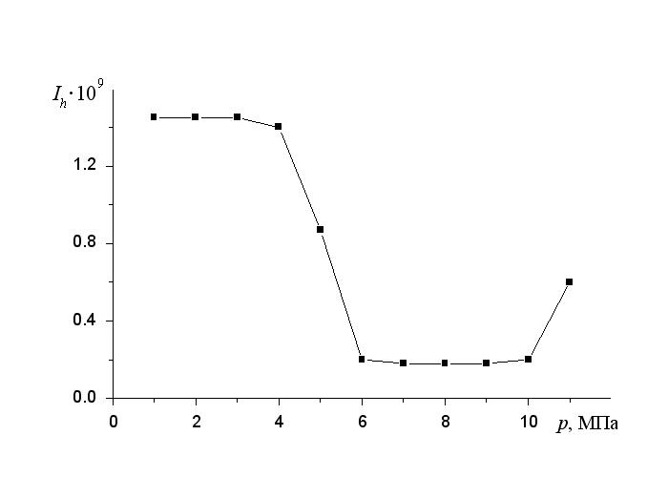 | 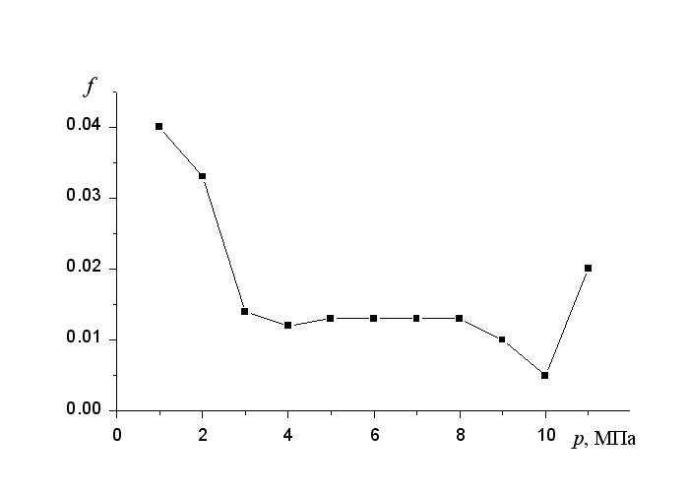
Fig.1. Dependences of intensity of outwearing (Ih) and a friction coefficient (f) from pressure on a surface of the titanium samples processed by microplasma discharges
This work was supported by the RFBR, projects 12-08-00849-а, 12-02-92699 ind-а.
References
- V.A. Ivanov, M.E. Konyzhev, L.I. Kuksenova, V.G. Lapteva, A.S. Sakharov, T.I. Kamolova, A.A. Dorofeyuk, S.N. Satunin, "Strong Localized Interaction of Microplasma Discharges with Titanium" // Plasma Phys. Rep. 2010. V. 36, No. 13. P. 1241−1246.

