Microwave Power Absorption by a Multipactor Discharge
on a Dielectric: theory, experiment, and computer simulations
Sakharov A.S., Ivanov V.A., Tarbeeva Yu.A., Konyzhev M.E.
A.M. Prokhorov General Physics Institute, Russian Academy of Sciences, Moscow, Russia, sakh@fpl.gpi.ru
The coefficient κ of microwave power absorption by a single-surface multipactor on a dielectric is studied analytically and numerically as a function of the incident microwave power. In solving the problem numerically, the formula for the secondary emission yield δ(ε) proposed in [1] is used (Fig. 1, curve 1). For the traditionally employed simplified formula with a zero cut-off energy ε₀ (Fig. 1, curve 2), the following asymptotic expression for κ is derived analytically for electron oscillation energies ε_{osc} much higher than the first crossover energy ε₁, at which δ(ε₁) = 1:
(1)
where v_{Te} is the thermal velocity of secondary electrons.
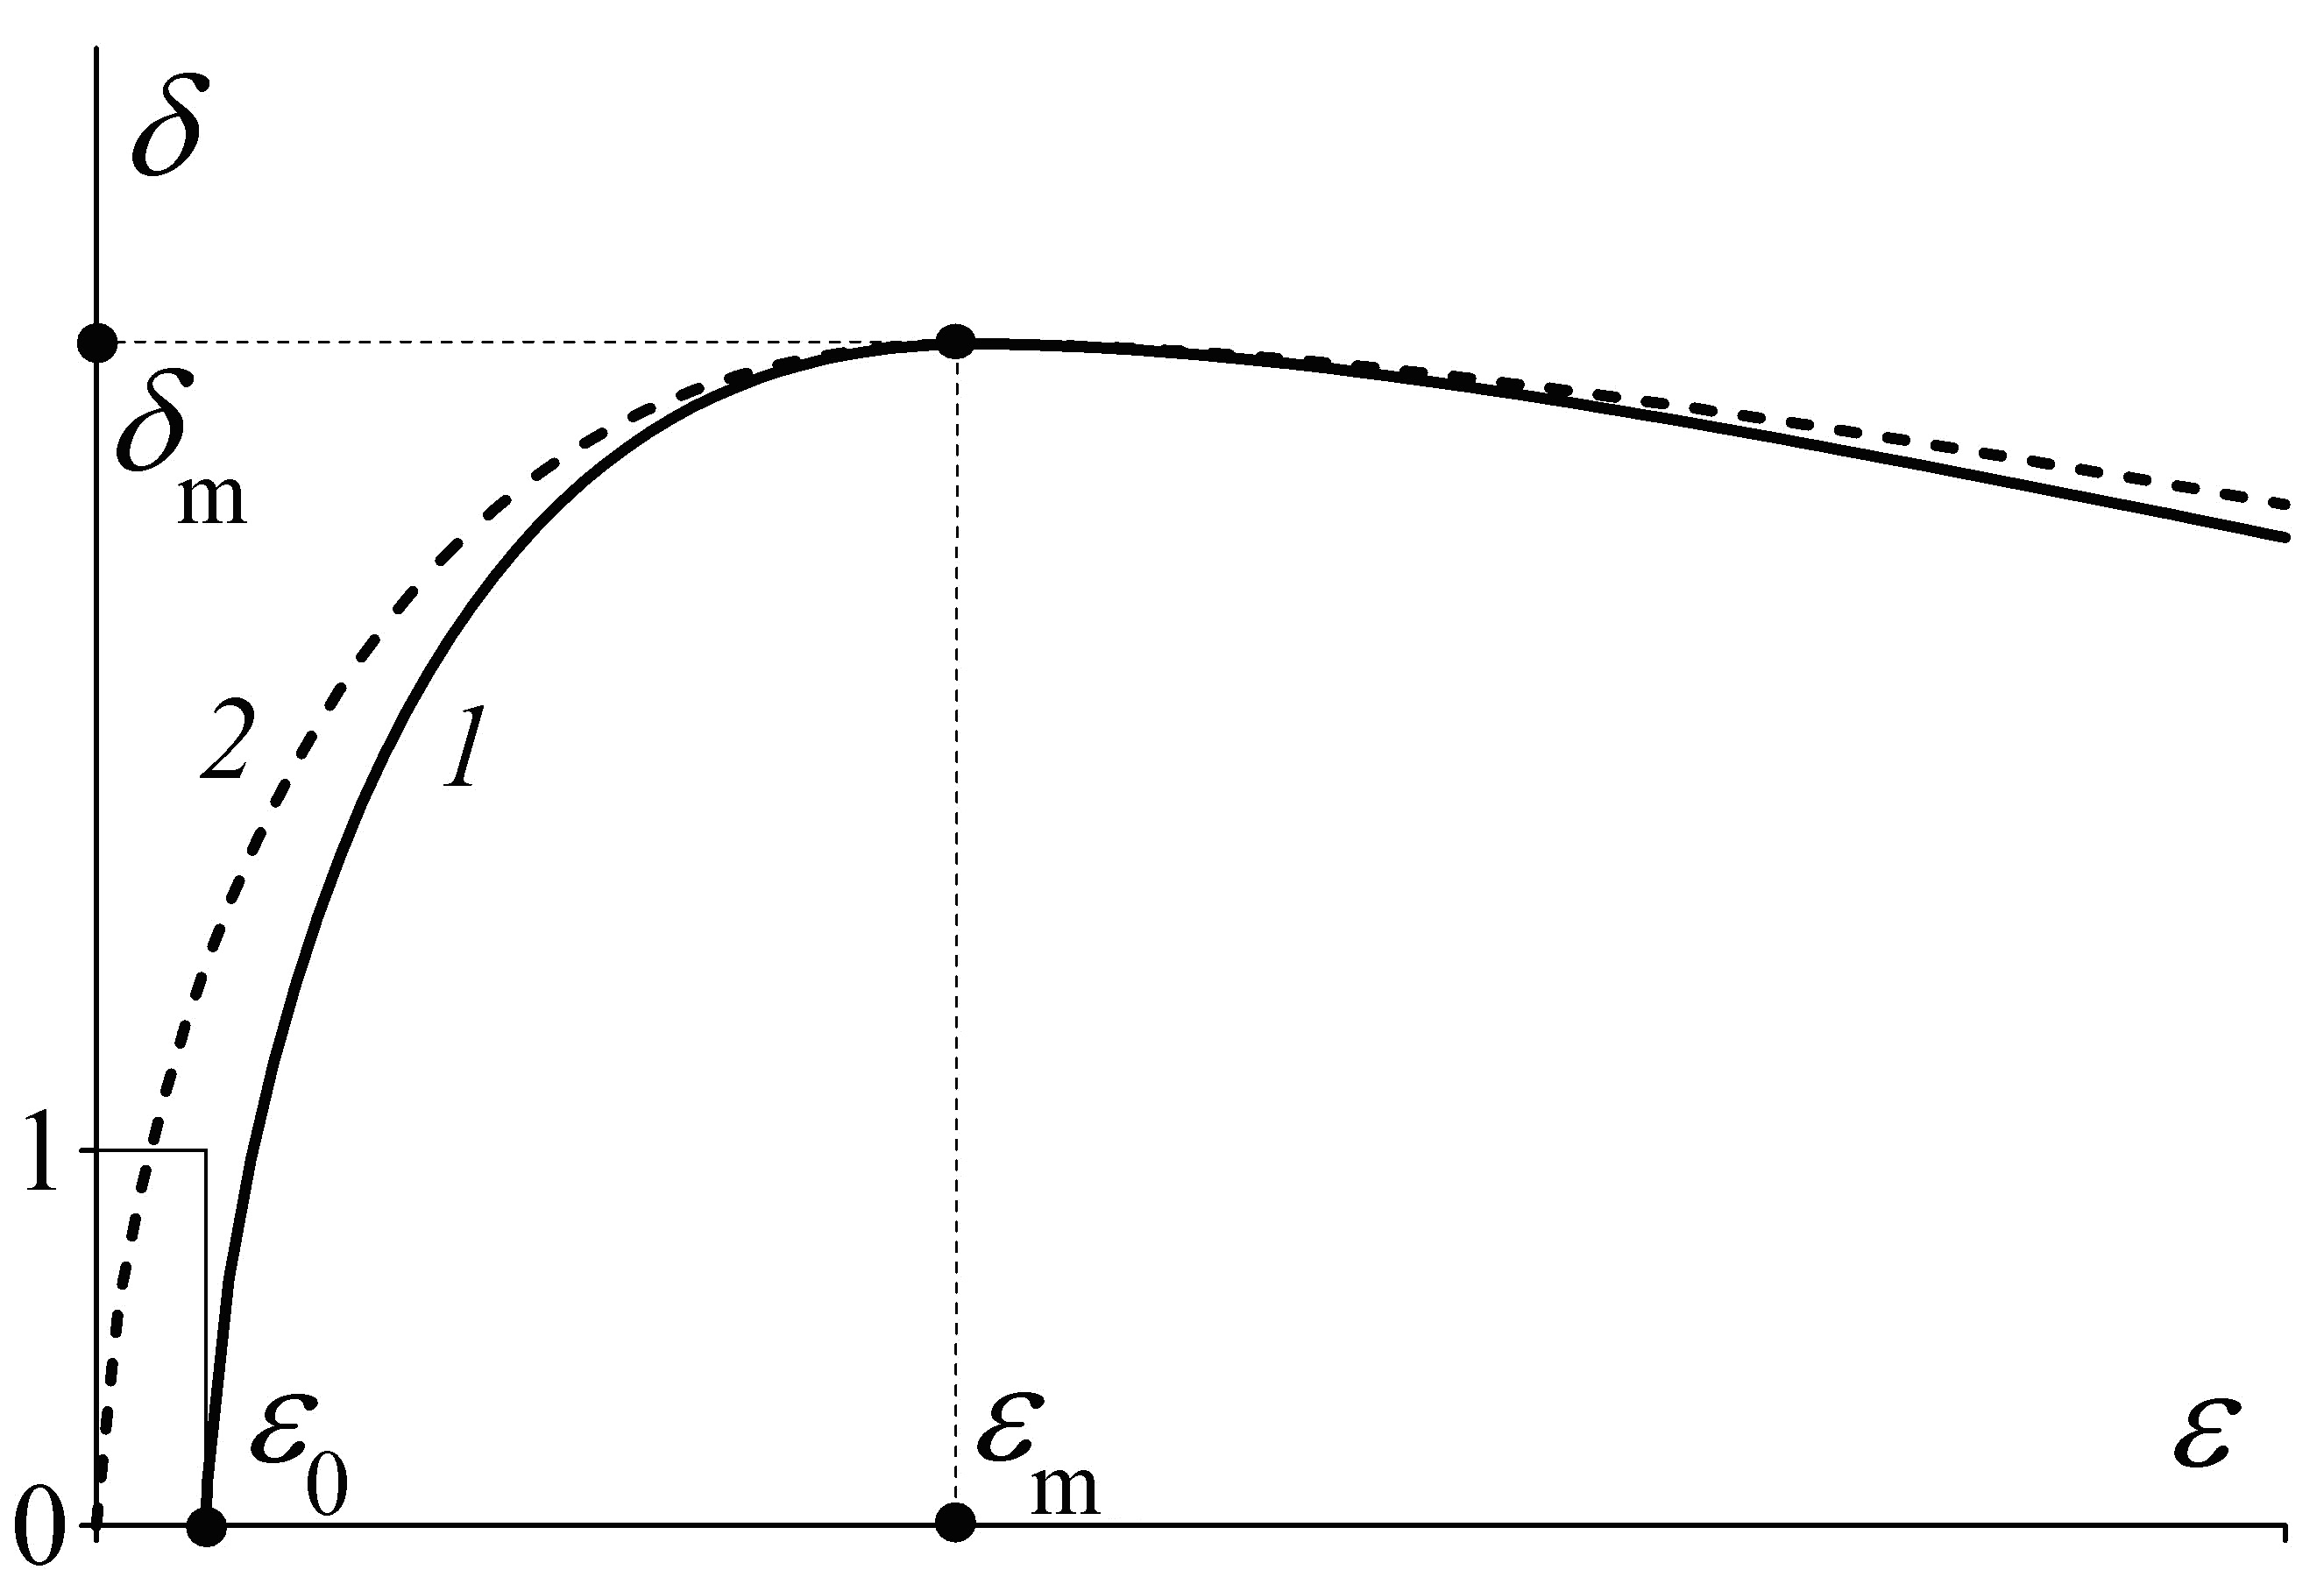
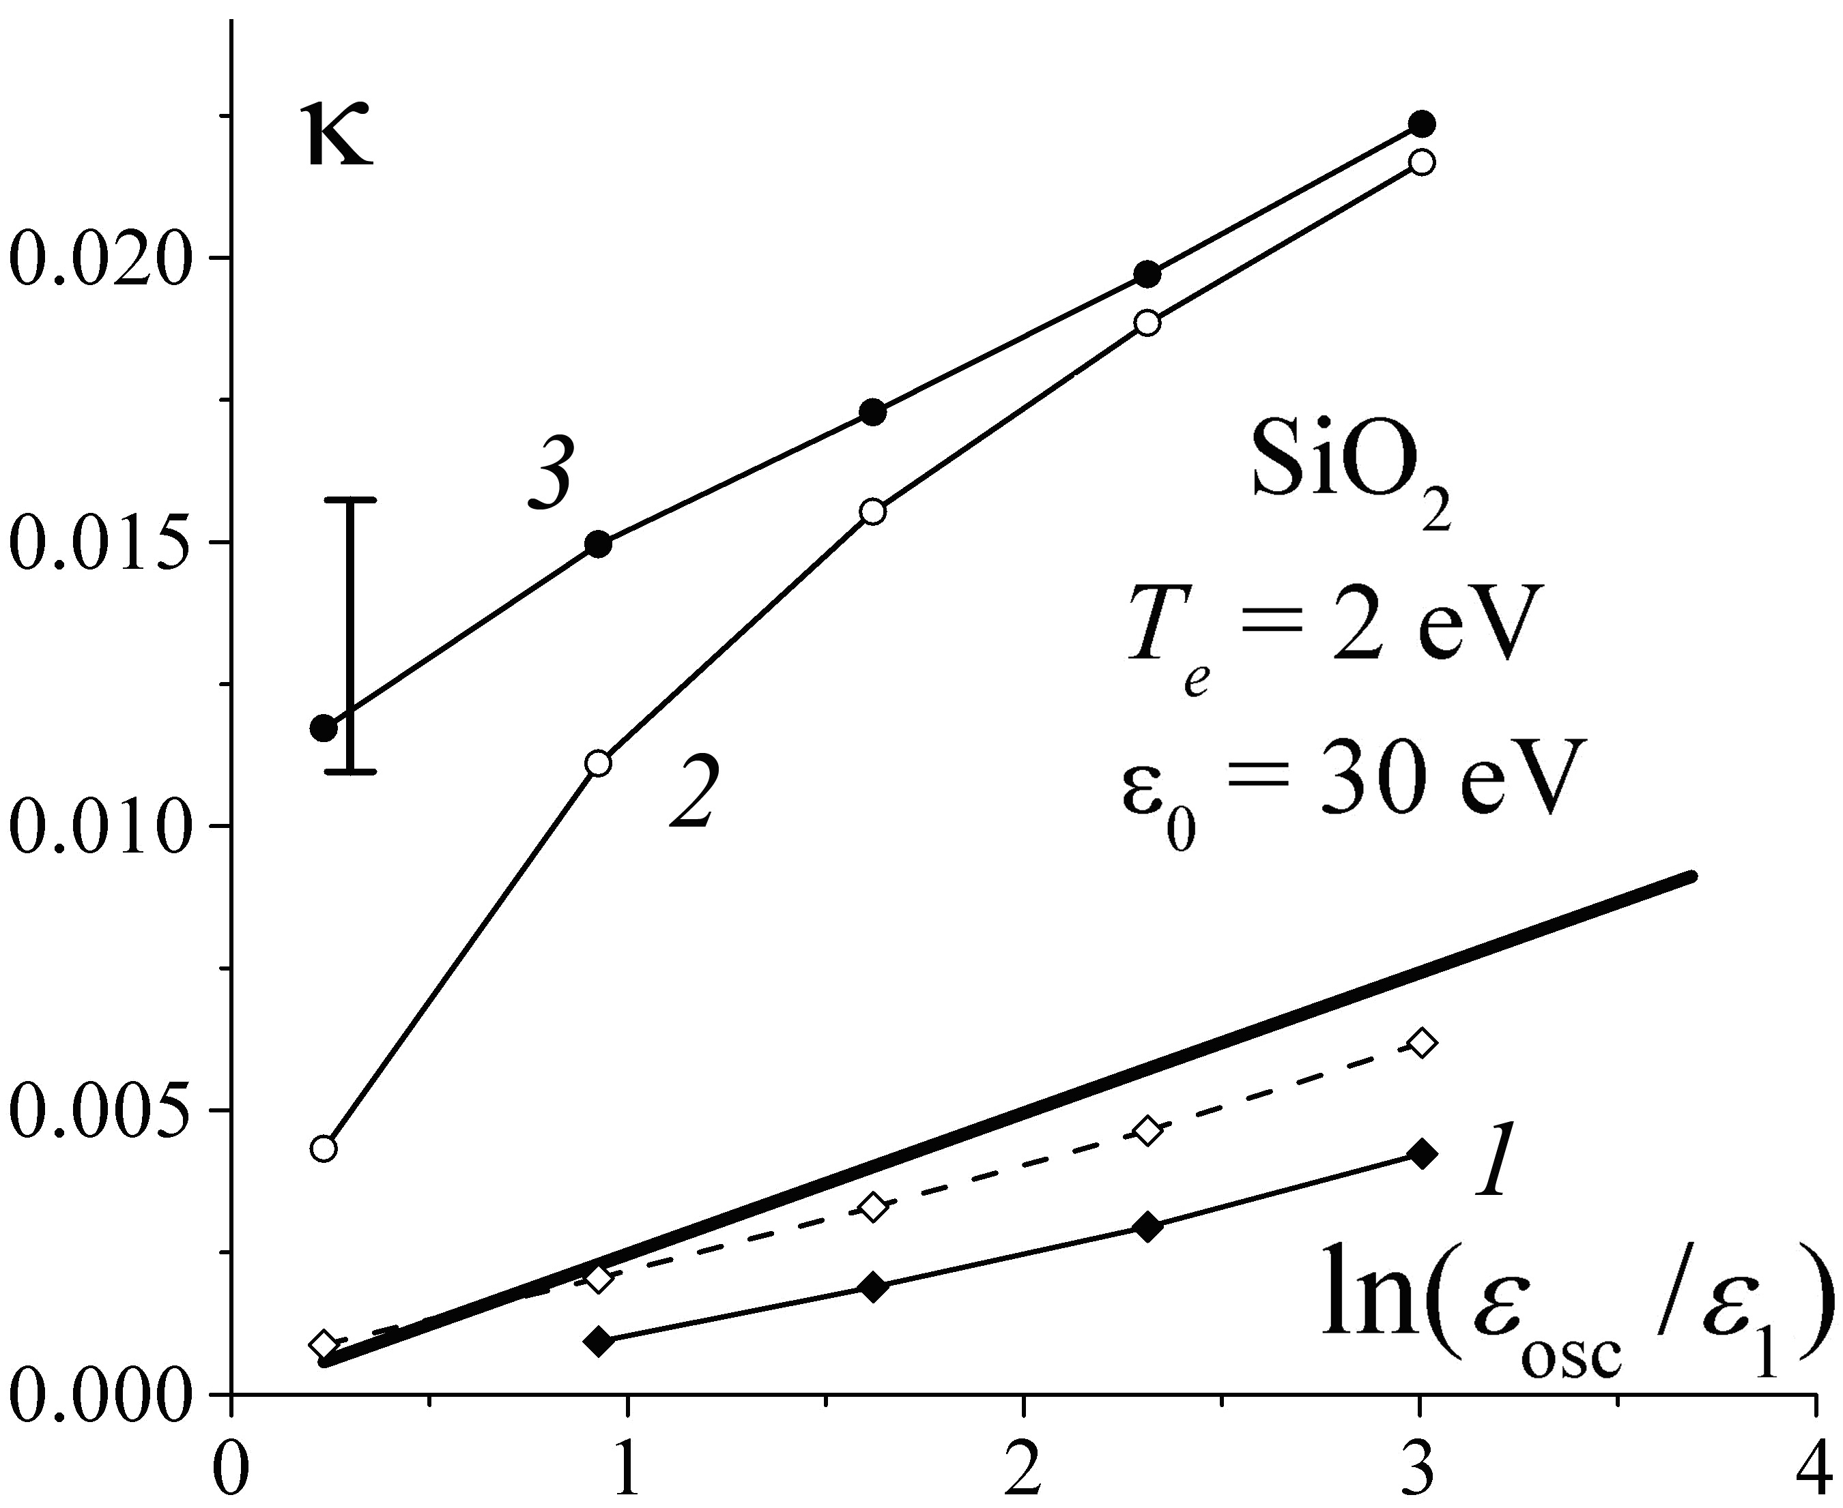
It is shown with the help of 1D3V numerical simulations that taking into account electron reflections from the dielectric surface substantially increases the coefficient of microwave power absorption. The analytical and numerical results are compared with the experimental data.
Fig. 1 Fig. 2
Fig. 1. Secondary emission yield δ as a function of the incident electron energy ε: (1) formula [1]; (2) simplified formula [1] with ε₀ = 0. The step at ε < ε₀ shows the addition to δ introduced in [2], which corresponds to electron reflections with a coefficient of R = 1 at low values of ε.
Fig. 2. Coefficient of microwave power absorption κ(ε_{osc}) for glass (SiO₂), obtained in numerical simulations with the use of the formula [1] with ε₀ = 30 эВ: (1) without allowance for electron reflections, (2) with the coefficient of elastic reflection R = 1 at ε < ε₀ (see Fig. 1), and (3) with additional elastic and inelastic reflections at ε > ε₀ with the coefficients R = η = 0.1. The heavy line shows analytical dependence (1). The dashed line shows the result of numerical simulations with the use of the simplified formula [1] (ε₀ = 0) without allowance for electron reflections. The vertical bar shows the range of κ values obtained in the experiment carried out on the BRUS setup at the input microwave power of P_{input} = 85 kW.
This work was supported by the Russian Foundation for Basic Research, project nos. 12-02-00443-а and 12-08-00849-а.
References
- Vaughan J. R. M. // IEEE Trans. Electron Devices. 1988. V. 35. P. 1172.
- Vicente C., Mattes M., Wolk D. et al. / MULCOPIM-2005, Noordwijk, 2005. P. 11.

