SIMULATION OF CAPACITIVE RF DISCHARGE WITH EXTERNAL MAGNETIC FIELD WITH DOMINANT RADIAL COMPONENT
I.I. Zadiriev, K.V. Vavilin, M.A. Gomorev, E.A. Kralkina, V.B. Pavlov, V.P. Tarakanov*
MSU, Faculty of Physics, ekralkina@mail.ru
*IVT RAN, karat@tarak.msk.su
This paper presents the results of numerical simulation using the PIC method of a capacitive RF discharge, which was ignited in the discharge channel with the geometry close to Hall plasma thruster (see Fig.1). RF voltage was applied to two electrodes. One of them was in the region of the cathode, and the second was in the region of the anode of the Hall Thruster. In the simulation, the second electrode was separated from plasma by a dielectric layer. The magnetic field in the channel had mainly radial direction.

In the simulation it was assumed that the plasma consists of neutral xenon atoms, electrons, and singly charged ions. It was assumed that electrons were born with a probability of 0.3 due to the collision of ions with the channel walls and the dielectric separating the second electrode from plasma. The concentration of xenon atoms was assumed to be 10¹⁴ cm⁻³.
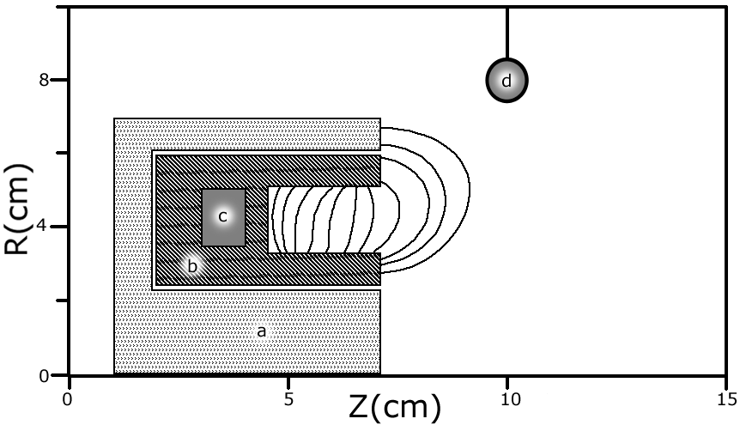
Fig. 1.Geometry of the model and magnetic field configuration. . a – metal, b – dielectric walls of the channel, c – active electrode,
d – grounded electrode.

Simulation showed that potential drops appear near the dielectric that separates the second electrode with plasma and near the channel cut off (see Fig.2). The appearance of the longitudinal electric field and the presence of a radial magnetic field lead to the occurrence an azimuthal drift of electrons. This in turn leads to the formation of plasma in a channel with a density exceeding 10¹¹ cm⁻³. In addition, the electric field produced near the channel cut off, leads to an acceleration of the ions and the formation of the jet at the exit of the plasma source.
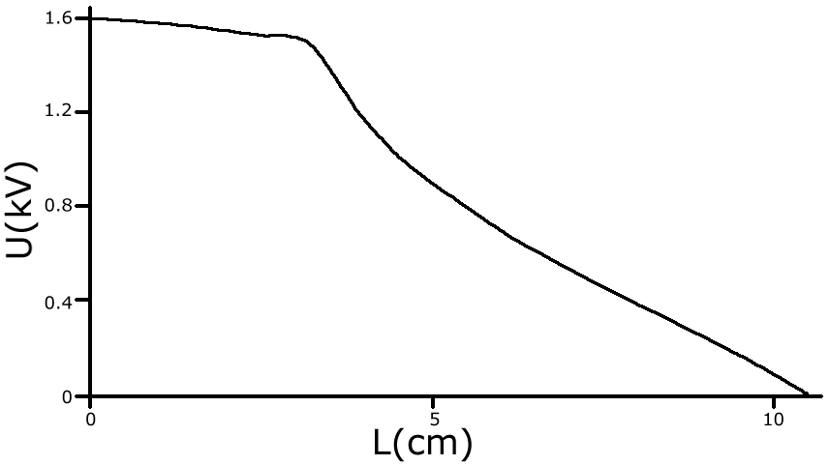
Fig. 2. Distribution of plasma potential along the channel.

Literature.
- Tarakanov V.P., User's Manual for Code KARAT, BRA, Inc., V.A., USA, (1992) 139.

