Self-organization patterns in the anode spots and fluctuations of dc glow discharge parameters in atmospheric pressure helium
V.I. Arkhipenko, Y.A. Safronau, L.V. Simonchik, I.M. Tsuprik
^{P}Stepanov Institute of Physics NASB, Minsk, Belarus, e-mail: simon@imaph.bas-net.by
Self-organization of the current spots on electrodes in patterns with pronounced symmetry was manifold described in the last century [1]. They impact considerably on homogeneity and stability of discharges. However, multiple observations of formation and self-organization of current spots on electrodes were found complicated for theoretical description. Recently, there is an increasing interest to these phenomena in connection with atmospheric pressure glow discharges (APGD) [2, 3]. In the given report, anode spots formation in dc helium APGD is studied and the correlation of spots intensity behavior with discharge parameters fluctuations is established. In the experiments, two- and three-electrode configurations of APGD were used [4, 5].
In the two-electrode configuration [4], the APGD is ignited between flat copper electrodes in a hermetic discharge chamber. Helium flow of about 1 l/min at atmospheric pressure is provided through the chamber. It is possible to obtain one (Fig. 1a, anode is located above), two and etc anode spots at the variation of discharge current or interelectrode gap. At the currents of tens and more milliamps stable anode patterns form (Fig. 1b). They disappear at the of anode region contraction occurring at the current of a few Amperes. The correlation dependences between the fluctuations of the anode spot intensity, voltage and current are established. It is shown, that a synchronization of spot fluctuations takes place for several discharge parameters leading to regularization of the current and voltage fluctuations.
a b
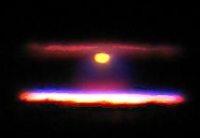
Fig. 1.
a b
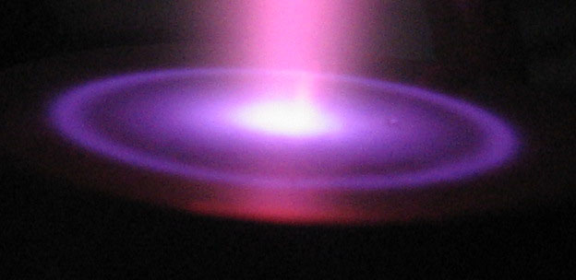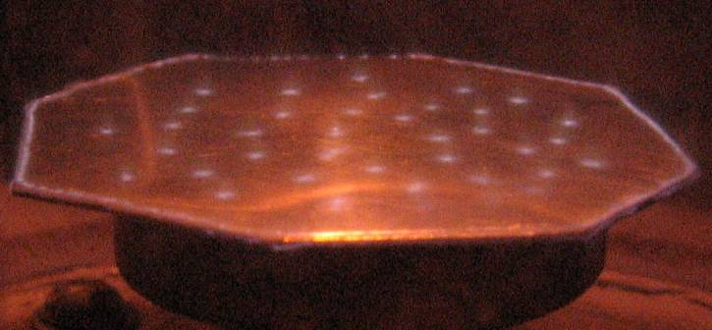
Fig. 2.
In the three-electrode configuration, [5], the distance between plasma cathode and the third electrode (second anode) is 2–5 cm. That allows to observe the patterns on the anode in large scale. Diameter of the ring structure in Fig 2a, for example, is larger than 2 cm, and the anode spots in Fig. 2b are located on the area larger than 15 cm².
Financial support of BRFBR-CNRS grant F11F-002 is acknowledged.
References
- K.G. Emeleus, International Journal of Electronics, 52 (1982) 407.
- T. Verreycken, P. Bruggeman and C. Leys, Journal of Applied Physics, 105 (2009) 083312.
- N. Shirai, S. Ibuka and S. Ishii, Applied Physics Express 2 (2009) 036001.
- V. I. Arkhipenko, A. A. Kirillov et al, Plasma Sources Science and Technology, 18 (2009) 045013.
- V. I. Arkhipenko, A. A. Kirillov et al, IEEE Trans. Plasma Sci., 37 (2009) 740.

