The quantization of Langmuir waves and superconductivity of plasma
B.A.Veklenko
Joint Institute for High Temperature of Russian Academy of Science, 127412, Moscow, Ijorskaja 13/19, Russia, e-mail: VeklenkoBA@yandex.ru
The longitudinal Langmuir oscillations of the cold () electron –ion plasma possesses the quantum properties as any electromagnetic field oscillations. The quantum properties create the electromagnetic vacuum. If the places of ions are fixed, then the interaction of electrons through electromagnetic vacuum leads to their mutual attraction and creation at of the superconductive energy gap. In this paper the properties of electron –ion plasma are investigated on the base of quantum electrodynamics. We use the Bogolubov method of Green functions and breaking up the correlators using Gorkov method. The real case ( -Langmuir frequency, -Fermi energy) is considered. For the energy gap at in rationalize unit system CGSE the following formula is got
, . ()
-being the electron charge,
, .
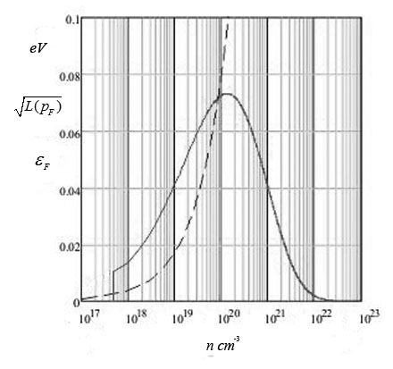
This formula does not contain the fitting parameters. But the energy gap calculated according to it is too big. It means that the interaction in real conditions is described by effective charge while. Formula is very sensible to the value of . On the figure the dependencies (solid line) and (dashed line) are plotted versus electron concentration at . One pays attention to local maximum of at respectively small that responses the critical superconductive temperature. The less the lager .The question is why for consent to experimental data it is necessary to diminish the charge till in formula.

