Dynamics of plasma at electro exploding wire in a cross-section magnetic field
G.I. Dolgachev, Yu.G. Kalinin, D.D. Maslennikov, А.А. Shvedov
National Research Centre "Kurchatov Institute", Akademika Kurchatova Sq, Moscow,
123182 Russia, e-mail: shvedov@live.ru
In the program "Baikal" for experiments in the field of inertial controlled fusion a final step of an impulse aggravation is a plasma opening switch (POS) in an external magnetic field. One of conditions of its working capacity - a constancy of parameters of the plasma created by plasma injectors (PI). It is known that the exit on optimum POS operating mode demands a quantity setter start-up which on large installations are expensive enough. Therefore there is a question on an exit on a mode from the first shot without preliminary training PI – a problem of first "shot". It is especially important at a capacity aggravation magneto cumulative current generators where first "shot" is also the last. For the decision of this problem researches of dynamics of filling backlash with an external magnetic field by means of electro exploding wires are conducted. At wire explosion, i.e. its full evaporation and ionization of steams, in a backlash in advance known quantity of plasma is formed, and, basically, it is possible to pick up the parameters at once providing optimum POS operating mode. Therefore it is offered to replace PI with a thin wire (or a set of wires), connecting POS electrodes and located across an external magnetic field, and to carry out its electro explosion by POS current, and necessary for inclusion of the current breakdown mechanism of a plasma parameters in backlash (n~10¹⁴ cm⁻³) to select at the expense of a material, diameter of a wire and use of dynamics of its scattering in a POS backlash. Optimism on successful filling of a POS backlash with plasma is installed by results of work [1] where it was revealed that the plasma channel originally localized in the form of "spoke" formed individual PI, not simply moved in an azimuthal direction as whole, and "was smeared" under the influence of force JхВ in process of current increase, forming as a result continuous ring (fig.1).
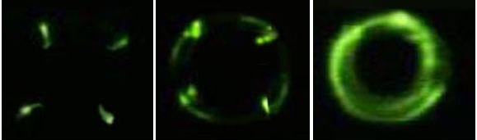  0,1 μs 0,42 μs 0,98 μs | Fig.1 3- exposure electrooptic photo of work of four coaxial PI at B_{Z} =60 kG where time in μs is counted from the beginning of POS current till the registration moment.

In work results of researches by means of a exposure electron-optical photo of dynamics of filling of ring backlash are resulted by plasma at wire explosion in an external magnetic field to 60 kG. Replacement of plasma guns on electro exploding wire ( EEW) should allow to leave at once in a mode without preliminary training and guns work checking. Besides, application EEW, giving particles density falling in time (from 10²³ to 10¹⁴ cm⁻³) in POS backlash presumes to solve characteristic problem for the "Baikal" program a long (~40 μs) preimpulse. Work is executed with support of President of RF grant № MK-2436.2011.2.

References
- Dolgachev G. I, Maslennikov D.D., Ushakov A.G., Fedotkin A.S., Hodeev I.A., A.A.Shvedov Dynamics of filling with plasma of a backlash of the plasma opening switch across a strong magnetic field.//Physics of plasma, 2011, volume 37, №2, p. 193-198

