CURRENT PROGRESS ON PORT PLUG TEST FACILITY FOR ITER IN RF
Romannikov A., **Levesy B., Krasilnikov A., *Skorodumov B., *Rumyantsev Y., *Allin M., ***Cerisier T., *Besrukov K., *Kotusov S., *Kuzmenco I. and JSC “Cryogenmash” team.
ITER Agency, Russian Research Center «Kurchatov Institute», pl. Kurchatova I., 1,
Moscow 123182, Russia, a.romannikov@iterrf.ru
*JSC “Cryogenmash”, 143907 Moscow reg., Balashikha, Russia
**ITER Organization, Route de Vinon sur Verdon, 13115 Saint Paul Lez Durance, France
***CNIM, Z.I de Brégaillon 83507 La Seyne sur mer
To achieve the overall ITER machine availability target, the availability of diagnostics and heating port plugs shall be as high as 99.5%. To fulfill these requirements, it is mandatory to test the port plugs at operating temperature before installation on the machine and after refurbishment.
The ITER port plug test facility (PPTF) provides the possibility to test upper and equatorial port plugs before installation on the machine. Test stands shall be capable to perform environmental and functional tests.
Environmental tests consist of:
- 3 thermal cycling of the port plugs up to 240°C
- Helium leak check of the windows, penetrations and cooling circuits.
- Pressure and pressure drop tests of the cooling circuits
Functional tests consist of:
- Radio Frequency acceptance test and conditioning of the IC antennas
- Mirror alignment and behavior of the steering mechanism for the EC launchers
- Optical and micro-wave alignment and neutron calibration for the diagnostics systems
The test stands are composed of one vacuum tank (3.3m in diameter, 5.6m long) and the associated heating, vacuum and control systems. The vacuum tank shall achieve an ultimate pressure of 1x10⁻⁵ Pa at 100 °C containing a port plug. The heating system shall provide water at 240°C and 4.4 MPa to heat up the port plugs. Openings are provided on the back of the vacuum tank to insert probes for the functional tests.
This paper describes the tests to be performed on the port plugs and the conceptual design of the port plug test facility. The configuration of the standalone test stands and the integration in the hot cell facility are presented.

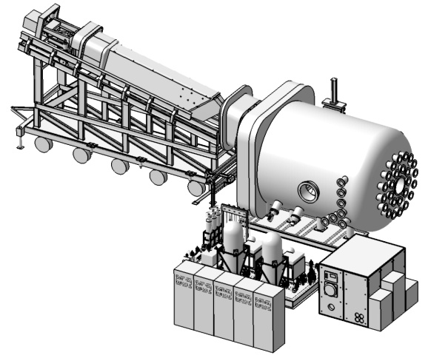
Test stand - Upper port plug configuration (test tank, heating, vacuum and control systems and handling tool)

