Hydraulic and electric characteristics of plasmatrons in the laminar and turbulent regimes and turbulent modes of plasma flows
O.A. Sinkevich, S.E. Chikunov*, E.Hh. Isakaev*
The Moscow Power EngineeringIinstitute (Technical university), Moscow, Russia,
e-mail: oleg.sinkevich@itf.mpei.ac.ru
*Institute for Hhigh Temperatures, Russian Academy of Science, Moscow, Russia
The specific features of hydraulic and electrical characteristics of stabilized plasma flows in plasmatron channels are investigated using the analytical solutions (the generalize Poiseuille profile [1]) and numerical calculations. Introduction of the effective Reynolds number Re_{ef} [2] helps naturally unite hydrodynamic and thermal influences on plasma flow. The method that is based on numerical calculations and experimental data and gives us possibility to determine the criterion of transition from a laminar regime of plasma flow to the turbulent one is proposed. In a wide range of experimentally investigated parameters (plasma flow rates, electric currents, diameters of the plasmatron channel) the given method has allowed to reveal the border dividing laminar and turbulent modes of plasma flows and to establish critical value of the effective Reynolds number Re_{ef.cr} = 2000. This critical value is relevant to the Kelvin – Helmholtz instability of plasma flow. Use of the effective Reynolds number allows to construct hydraulic and electrical characteristics of plasma flows in the laminar and soft turbulent regimes in the plasmatron channel (Fig. 1 a, b).
Numerical modeling and experimental researches of currents of plasma on the stabilized site плазмотрона show, that nonmonotonic temperature dependence of dynamic viscosity over the channel cross section causes the emergence of two inflection points in the velocity profile.
References
- Sinkevich O.A., Chikunov S.E. The generalize Poiseuille profile in plasma flows in a stabilized region of a plasma generator. High Temperature. 2005. V. 43. No 2. pp. 165-174.
- Sinkevich O.A., Chikunov S.E. Critical Reynolds number in plasma flow on a stabilized plasmatron section. Fluid Dynamics. 2004. V. 39. No 5. pp. 718-728.
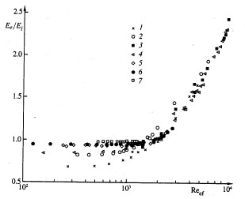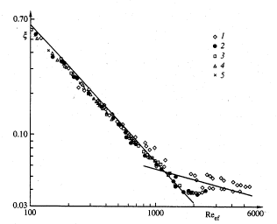
a b
Fig 1 a) Dimensionless electric field strength (points 1-7 correspond to 10, 20,40,50, 60,80 и 100 A, respectively), b) and friction drag as a function of the effective Reynolds number (points 1-5 correspond 60,80, 100, 150 и 200 A, respectively).

