INFLUENCE OF SCRAPE OFF LAYERS PLASMA PARAMETERS ON MHD-STABILITY IN GAS DYNAMIC TRAP
P.A. Bagryansky, *E.I. Soldatkina, A.L. Solomakhin
Institute of Nuclear Physics, Novosibirsk, Russia, e-mail: P.A.Bagryansky@inp.nsk.su
*Novosibirsk State University, Novosibirsk, Russia, e-mail: E.I.Soldatkina@inp.nsk.su
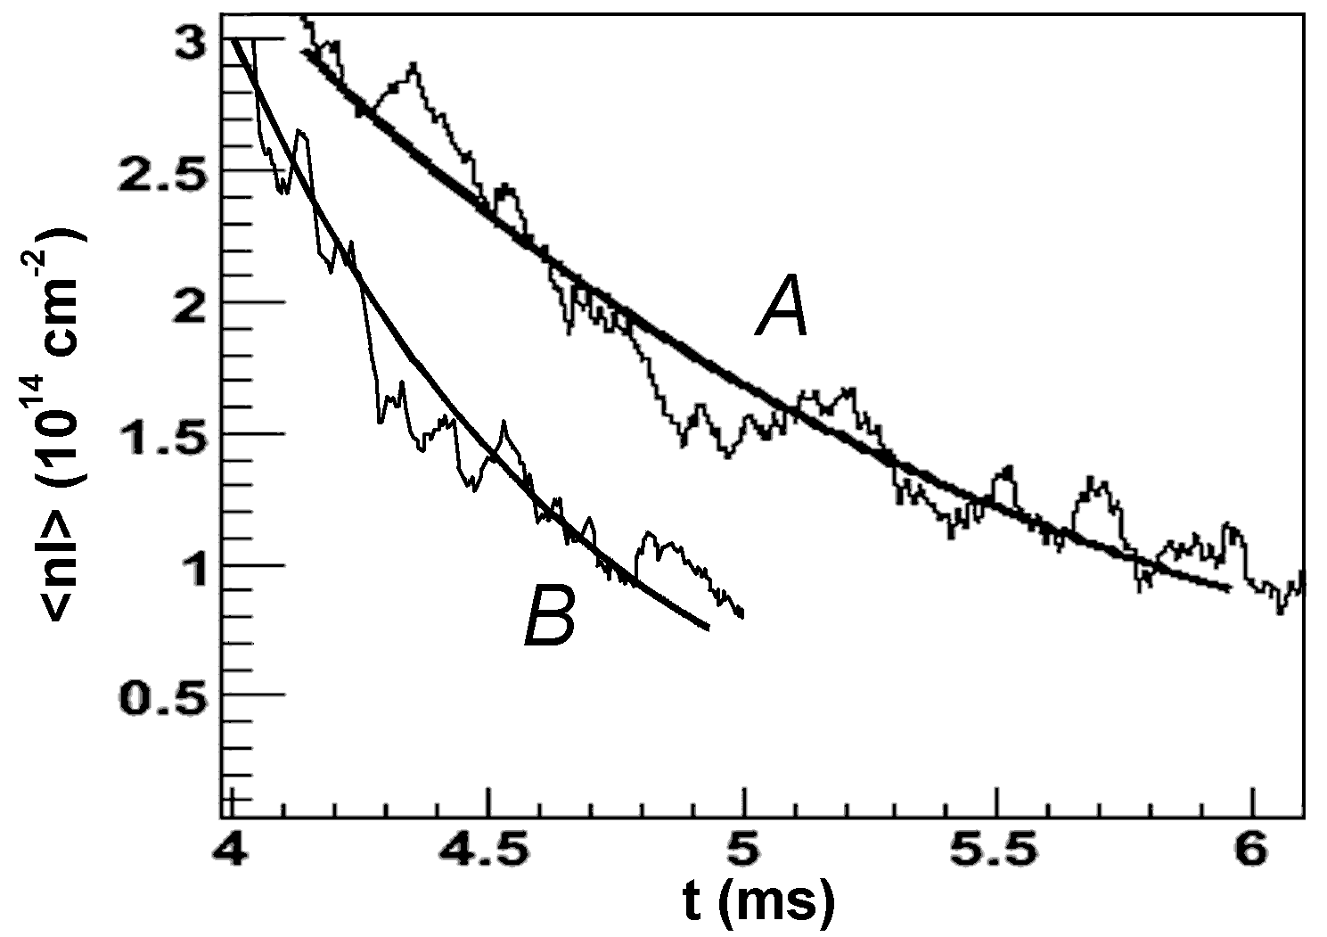
One of the most important subjects of the GDT research program is MHD-stability and transversal transport of high pressure two-component plasma. Influence of contact between plasma and end absorbers and influence of radial electric field profile on MHD-stability and transverse transport were investigated. Measurements which allow to estimate electric resistance between central cell and plasma absorbers were carry out. Results obtained are in a good agreement with flat probe theory. Using this results one can conclude that contact between plasma and end absorbers can have very significant influence on flute instability increment. Experiments of few last years were devoted to searching of the confinement regime stable relate to plasma centrifugal rotation in cross fields. Positive influence of radial electric field on the plasma confinement was demonstrated in previous experiments on the GDT in regimes without any special MHD stabilizers. In recent experiments it was observed that stable plasma confinement always corresponds to intermittent distribution of biasing potential on limiters and plasma dumps. It was shown that enhancement of plasma confinement time corresponds to the radial electric field on periphery in the range of 15 – 40 V/cm and one induces the sheared plasma rotation (see fig.1, curve А, target plasma decay time ~ 1.63 ms). Regime with grounding of all radial electrodes was typically unstable with plasma confinement time two times lower than gas dynamic flow time (see fig.1, curve B, target plasma decay time ~ 0.65 ms). Therefore sheared rotation can stabilize MHD modes of high β two-component plasma in the GDT experiment. It is also shown that contact between plasma and radial electrodes is essential but can not completely provide MHD stability in GDT.
Fig.1. Time evolution of target plasma line density
Measurements using special combined probe were carried out to study fluctuation induced transversal transport and allowed one to conclude that cross field transport is negligible and does not play essential role in regimes with sheared plasma rotation.
References
- P.A.Bagryansky, A.A. Lizunov et.al. Experiments with controllable application of radial electric field in GDT central cell. //Fusion Science and Technology - Vol. 43 - pp. 152-156.
- Rosenbluth M.N., Longmire C.L. Stability of plasmas confined by magnetic fields. // Annals of Physics - 1957. - Vol.1 - P.120.

