Helical waves on a sunspot surface as an example of heterogeneous dynamo
V.V. Glazkov, O.A. Sinkevich
Moscow Power Engineering Institute (Technical University), Moscow, Russia,
e-mail: oleg.sinkevich@itf.mpei.ac.ru
Helical waves of the finite amplitude on a surface of the conducting fluid are examined for generation of the magnetic field. Estimates are made for the differentially rotating cylindrical conducting fluid body, with the helical surface wave structure on its top, fig.1. This structure is similar to the self-exciting Faraday-disk homopolar heterogeneous dynamo [1], fig.2. For critical rotation rate Ω_{min}, we obtain $Ω_{\text{min}}≥\frac{4π}{μ_{0}}\frac{1}{σ\text{hL}\text{sin}\left(α\right)}$ . (1)
Magnetic Reynolds number R_{m} = σ μ₀ ΩL² = 4πL/hsin(α). (2)
For the generated magnetic field, $B\text{\sim }\sqrt{\left(\frac{2ρΩ}{σ}\right)}=\sqrt{\frac{8π}{μ_{0}}\frac{ρ}{σ^{2}}\frac{1}{\text{hL}\text{sin}(α)}}$. (3)
Here σ is the electric conductivity, μ₀ = 4π 10⁻⁷ is the permeability of the free space, α is the helical characteristic angle. Estimations of angular velocity and magnetic field magnitude for a sunspot on the surface of the Sun according (1)-(3) gives reasonable numbers and proves this hypothesis to be of value for further detailed analysis. As magnetic field generation by the helical structure is a surface effect, it is possible to find connection between Sun magnetic field structure and tide motions of the Sun surface cased by the planets. It also explains why solitary sunspots are observed.
As differentially rotating conducting helical structures are quite often observed in the nature [3], the same approach can be used to examine magnetic field generation process in various celestial bodies.
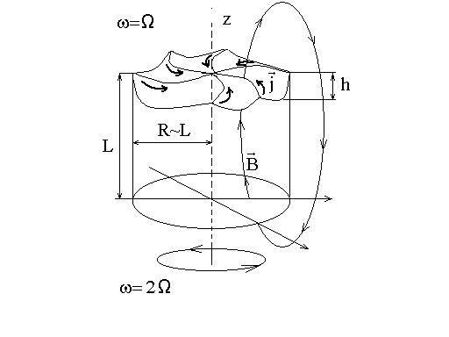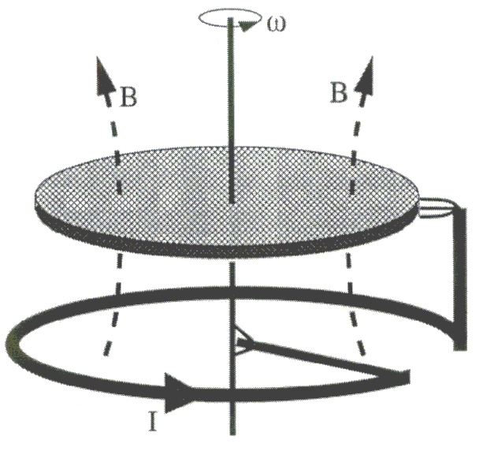
Fig. 1. Rotating cylinder with helical structure on the top. Fig.2. The Bullard's disk dynamo (after [2] ).

