effective algorithm for multidimensional modelling of glow discharge
A.S. Petrusev, S.T. Surzhikov
Russia, Moscow, IPM RAS, e-mail: petrusev@ipmnet.ru
The paper is devoted to numerical modeling of direct current normal glow discharge between two planar electrodes with the aid of drift-diffusion model at low pressures 1÷20 Torr. Due to a wide range of characteristic times of discharge processes, this system is stiff and hard for numerical solution [1]. The algorithm been developed has satisfactory convergence rate and economy of each iteration. It is based on combination of Thomas algorithm with relaxation. The continuity equations for ions and electrons are solved mutually by matrix Thomas algorithm with relaxation. Poisson equation and equation of thermoconductivity are solved independently by scalar Thomas algorithm with relaxation. At optimal values of relaxation parameters the necessary iterations number is 700-1500.
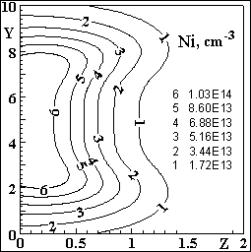
Fig. 1. The distribution of ions density at YZ plane.

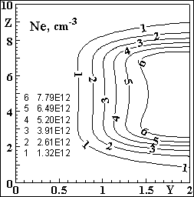
Fig. 2. The distribution of electrons density at YZ plane.
With the aid of proposed algorithm 3D modeling of glow discharge in nitrogen with Emf of power supply 2 кV and ballast resistance 300 kOhm has been conducted. The rectangular calculation area 0≤x,y≤10 cm, 0≤z≤2 cm and rectangular mesh with 100×100×200 nodes have been used. The electrodes are in XY plane. The mesh is non uniform in Z direction at near electrodes areas.
The results of calculation for pressure 1 Torr are on Fig. 1, 2. The gas heating is not significant, but important changing in discharge structure have been found in radial direction. The maximums of charged particles concentrations and anode current density are displaced from symmetry axis to periphery and the structure of discharge becomes torus. It should be mentioned that in accordance with classical Engel-Steenbek theory in almost all calculation area the discharge plasma is far from neutrality. So the using of quasineutral models in aerophysical research at low pressure is inadequate or it demands additional substantiations.
References
- Surzhikov S.T., Shang J.S. Journal of Computational Physics., 2004, v199, p.437.

