A New Method of Forming Compact Toruses
A. Mozgovoy
P.N. Lebedev Physical Institute, Moscow, Russia, 119991, Leninsky pr., 53
The compression of plasma and its subsequent heating is the key process in internal thermonuclear fusion.
It was precisely the study of compression processes (pinching) of linear currents that began investigations in the fifties in the Soviet Union. At present, work is continuing on X- and Z-pinches with megampere currents. The achieved results, however, do not permit us to hope that a reactor with positive energy output can be created by this method. The study of longitudinal pinching of a wide, short-circuited current loop is of no less interest. Such a configuration of plasma was investigated in theta pinches, compact toruses or FRC -Field Reserved Configuration/.
In contrast to a usual pinch, in such a turn a large amount of magnetic energy can be stored (as in a single-turn inductive ring), and compression of the torus along the axis should secure heating of plasma. Earlier methods of forming toruses were of very low efficiency.
The essence of this new, patented method is the following (see Figs 2 and 3):

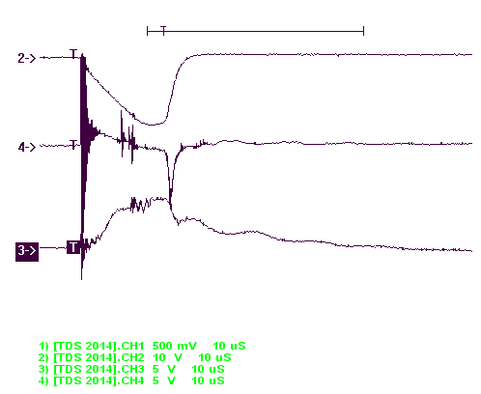
○ ○ ○ ○ ○ ○ ○ ○ ○ ○ ○ ○ ○
…………………………………………………………………………………………………………………………………………………………………………………………………………………………………nnnnnnnnnnnnnnnnnnnnnn...g
…………………………………………………………………………………………………………………………………………………………………………………………………………………………………………………………..……..

.. ………………………………………………………………………………………………………………………………………………………………………………………………………………………………………………………………..
…………………………………………………………………………………………………………………………………………………………………………………………………………………………………………………………………....
○ ○ ○ ○ ○ ○ ○ ○ ○ ○ ○ ○ ○

F Fig. 1. Fig. 2.

Fig.1. 1 — plasma, 2 — solenoid (inductive store), 3 — exploding wire, 4-current monitor, 5 — main switch; C —capicity banks (12 mF,40 kV), U — voltage divider, R — magnetic probe, F — Forces in plasma layer, B — solenoid magnetic line, H — circular magnetic line, I — current in the central rod.
Fig. 2. 1 — current in solenoid (20 kA at maximum, 20 microseconds until max.), 2 — voltage on exploding wire
(80–kV at max.), 3 — magnetic field in the center.

Sequence:
- Magnetic field energy is accumulated in the solenoid.
- Plasma is created in the working volume of the solenoid before reaching maximum current.
- Additional circular magnetic field is created (as in a short-circuited coaxial). It is as if the solenoid is located coaxially in the coaxial. The net magnetic line acquires a helical form.
- Current in the solenoid is cut off, whereby in the plasma there arises current striving to maintain the magnetic flux.
- The solenoid is fed by current in the reverse direction to compress the compact torus in the radial direction.
Additional circular field leads to a sharp increase in the efficiency of flux capture.
In experiments with about 50 kJ, efficiency reached 70%.

