RADIO EMISSION GENERATION IN THE SOLAR FLARE CURRENT SHEET
A.I. Podgorny, *I.M. Podgorny, **N.S. Meshalkina
Lebedev Physical Institute RAS, Moscow, Russia, e-mail: podgorny@fian.fiandns.mitp.ru
*Institute for Astronomy RAS, Moscow, Russia, e-mail: podgorny@inasan.ru
**Institute for Solar-Terrestrial Physics SO RAS, Irkutsk, Russia, e-mail: nata@iszf.irk.ru
The comparison of results of solar flare May 27, 2003 numerical 3D MHD simulations with distribution of the radio-emission brightness temperature obtained by observations on the SSRT radio telescope (Irkutsk) provides the evidence of energy release in a current sheet (CS) above the active region AR 0365. The CS appears in the vicinity of a singular line due to focusing of disturbances, which propagate from the solar surface (photosphere).
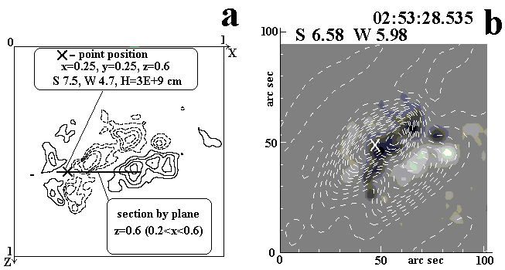
The method of setting of initial and boundary magnetic field from observed photospheric line-of-sight field component distributions is now developed. For this purposes the Laplas equation is solved with an inclined derivative as a boundary condition. To obtain stable numerical solution of resistive MHD equations the absolutely implicit scheme conservative relative to the magnetic flux is used. The flare at 02:53:28.54 produced strong increasing of the radio brightness temperature. The detected maximum of brightness temperature was 1.24×10⁷ Kº. The position of current density maximum of the CS obtained by MHD simulations (its heliocentric coordinates are S7.541 W4.692) is shown by cross oh Figure (a), where lines of equal normal component of photospheric magnetic field are presented (broken lines show negative field). Figure (b) represents lines of equal intensity of radio emission and the flare magnetogram, the cross shows the brightness temperature maximum with heliocentric coordinates S6.58 W5.97. These flare positions obtained by MHD simulations and by radio observations coincide with exactitude better than 1º, which does not surpass the accuracy of calculations. This result confirms the flare electrodynamical model [1,2] and opens possibility to use MHD simulation for essential increase of solar flare prognosis quality.
References
- Podgorny, A. I., Podgorny, I. M. Solar Phys. 1992, 139, 125.
- Podgorny, A. I., Podgorny, I. M. Астрон. Ж. 2001, 78, 71.

