New evidrnce OF SOLAR FLARE ELECTRODYNAMICAL MODEL Cenario
I.M. Podgorny, *A.I. Podgorny
Institute for Astronomy RAS, Moscow, Russia, e-mail: podgorny@inasan.ru
*Lebedev Physical Institute RAS, Moscow, Russia, e-mail: podgorny@fian.fiandns.mitp.ru
The flare electrodynamical model is based on numerical 3D MHD simulation of energy accumulation in the current sheet (CS) magnetic field [1, 2]. The thin lines and arrows show magnetic lines; thick lines and arrows show field-aligned currents. The energy storage in a preflare state about 10³² erg has been demonstrated. According to the flare electrodynamical model CS appears in the vicinity a singular line above an active region due to disturbances propagating from the photosphere. During quasistationary evolution CS transfers into unstable state, and explosive energy release occurs. The primary energy release and X-ray thermal emission must appear in corona above an active region. Others two hard X-ray emissions are produced by precipitating electrons accelerated in field-aligned currents. During CS decay Lorenz electric field applied along the singular line can generate solar cosmic ray.
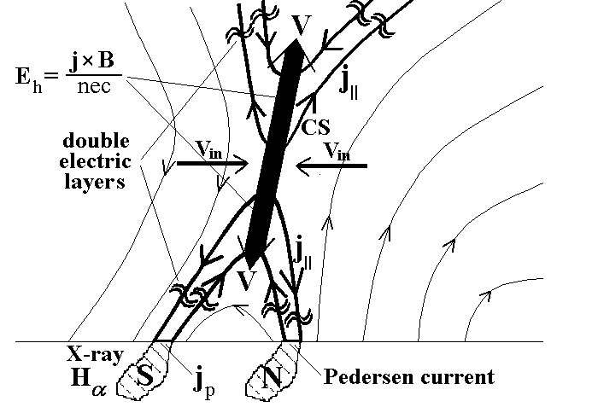
The recent flare observations on the solar limb by HERSSI [3] space craft demonstrate thermal X-ray (T ~ 10keV) source in corona and two photospheric sources produced by ~100keV electron beams. The spectra of solar cosmic ray were investigated by worldwide neutron monitor network [4]. The exponential energetic spectrum of solar cosmic ray is in agreement with a mechanism predicted by the solar flare model.
References.
- Podgorny A. I., Podgorny I. M. Solar Phys. 1992, 139, 125.
- Podgorny A. I., Podgorny I. M. Astron. Rep. 2001, 45, 60.
- http://sprg.ssl.berkeley.edu/~krucker/hessi/clean_real.html
- Balabin Yu. V., Vashenyuk E. V., Mingalev O. V. Podgorny A. I., Podgorny I. M. Astron. Report. 2005, 49, 837.

