On issue of spatial distribution of electrical explosion products of single wire
Yu.T. Sinyapkin
Russian Federal Nuclear Center – VNIIEF, Sarov, Russia, e-mail: mailbox@ntc.vniief.ru
Investigations of multi-wire liner systems, being carried out both in Russia and in foreign laboratories, the main goal of which creation of high-power pulsed x-ray source of magajoule range, are stalled due to recently discovered phenomena, impeding adiabatic self-constriction process. First of all this is heterogeneous absorption of electric energy on Z and X by a single wire and appearance of "kern" regime. Finally this leads to appearance of azimuth and axial heterogeneities at the end of a shell convergence, disturbing adiabatic regime. That is why it is impossible to get continuous (solid) plasma shell. Taking into account general gas-dynamic regularities we considered that large heterogeneities on the liner finish are consequences of small heterogeneities, i.e. their reasons are associated with the processes taking place on the start in the single wire. This work is devoted to investigation of this issue. It was preferable for us to study spatial mass distribution of exploding wire. Complexity and high cost of the equipment for spatial and time measurements lead us to creation of a method, called AUTOGRAPHY. Its main idea lies in absorption of scattered plasma-cluster-drop fragments with the target, located around the wire (a). Patterns obtained with this were densitometered (b) and, based on the results, we made a conclusion on a structure of mass spatial distribution of exploded wire, homogeneity of its scattering.
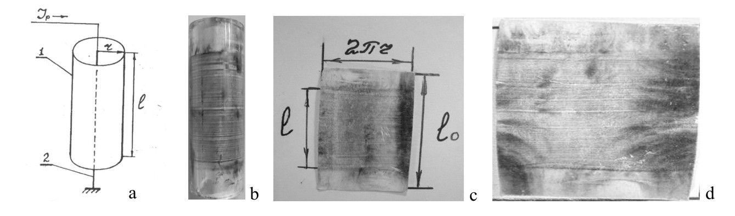
Experimental facility for multi-variant studies consisted of pulsed power source, based on lines with distributed parameters, hermetically sealed chamber for samples fastening, evacuation and gas filling unit of a discharger and the chamber, complex of measurement equipment to record electric parameters of the wire explosion process, and also instruments to control charging voltage and pressure in the discharger and working chamber. Results of experimental research have good reproducibility and make it possible to affirm that scattering products of electrical explosion of the single wire have a structure of successively located, relatively to the wire axis, self-organized toroidal-vortex formations from plasma-cluster fragments. Multiple investigation results showed that the structure is sensitive to experimental conditions and depends on wire material, its length, diameter and surface clarity, type and pressure of surrounding air, current and voltage of the power source.

