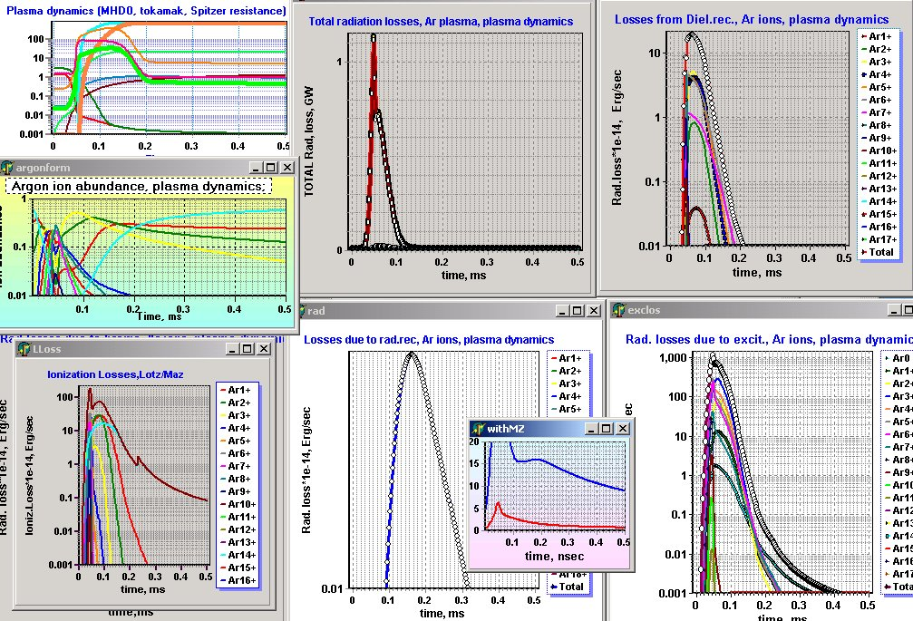
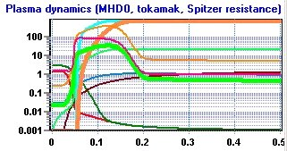
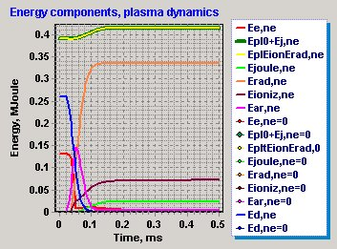
Deuterium energy
<Z>
Ne
Ni
Te
Ti
Ibeam1,kA
E,V/m
Ibeam2,kA
U,Volt
Joule heating in the presence of electron beam
Rad. losses in argon
Argon thermal energy
Electron thermal energy

