СПЕКТР ЭЦИ НА 2-м РЕЗОНАНСЕ
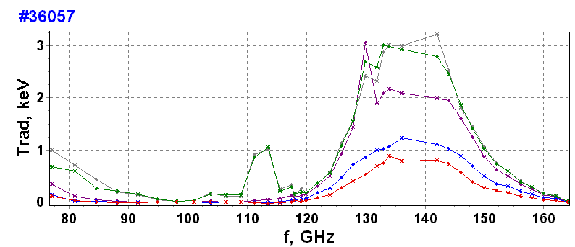

Fig. 1b
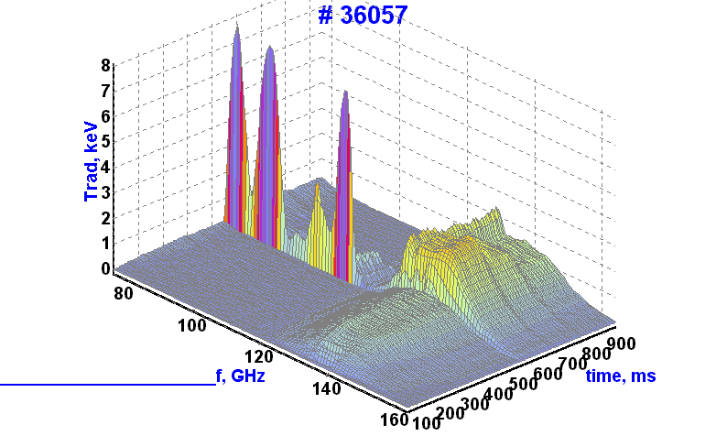
Tree-dimensional graph on fig. 1b shows that, except quasi-stationary part, spectrum contents also fast oscillating components with amplitude up to 10 keV during 10 ms after beginning of ECH. Fig.2a shows spectrum in O-mode on 1st resonance. Thermal distribution is similar to that on 2nd harmonic in general but some wider. Super thermal part is different in principal. Level of emission on first stage of discharge can reach 10 keV

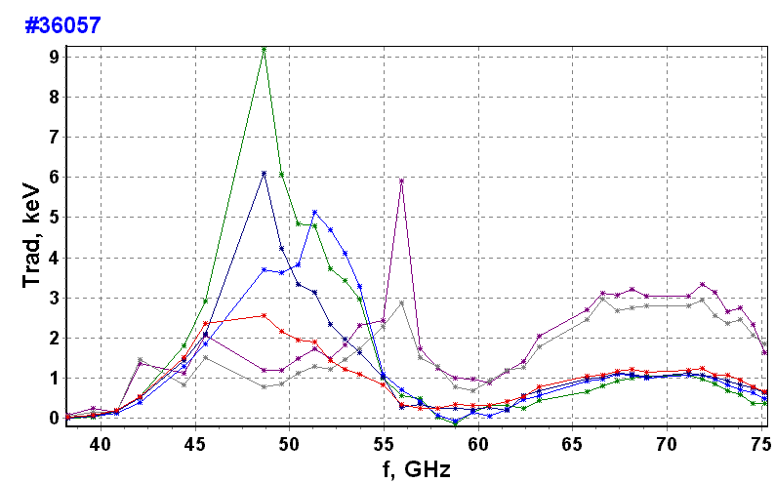
СПЕКТР ЭЦИ НА 1-м РЕЗОНАНСЕ
1 – 200 ms
2 – 300 ms
3 – 350 ms
4 – 500 ms
5 – 580 ms
6 – 650 ms

2
3
1
4
5
6
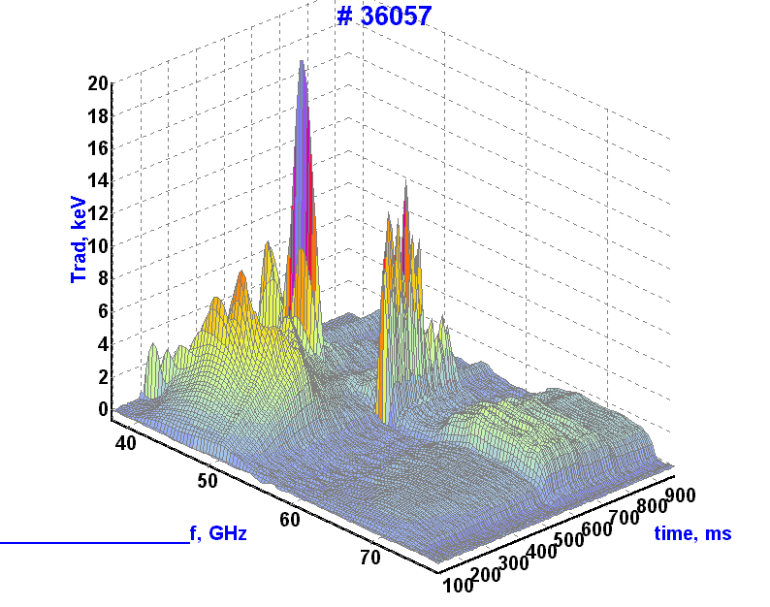
Periphery emission is accomplished by the oscillating movement in frequency scale what testifies about corresponding change into energy spectrum of electron flux. The spikes with duration 30 – 100 mcs and repetition ~ 3 and 6 kHz (fig. 2b) can rise to several tens keV.

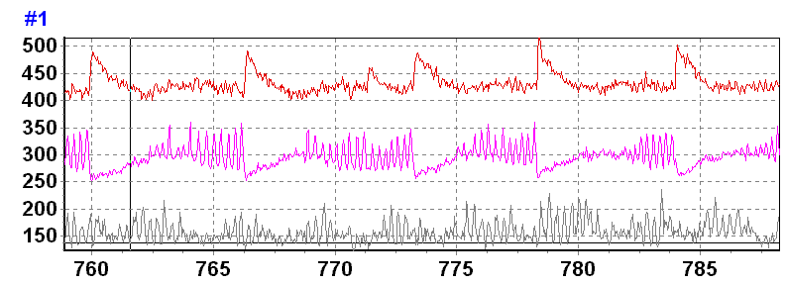
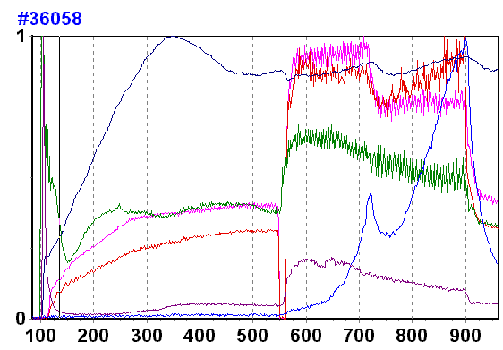

Fig. 2b

ECE 10 cm

ECE 6 cm
ECE 8 cm (q=1)
HF, total spectrum

ECE 6 cm
ECE 8 cm (q=1)

Light

Dalfa

Ne
Модуляция температуры при пилообразных колеьаниях не может быть объяснена вращением «острова» в тороидальном или полоидальном направлении

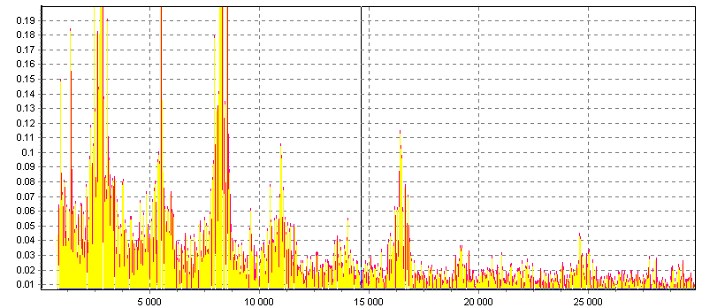
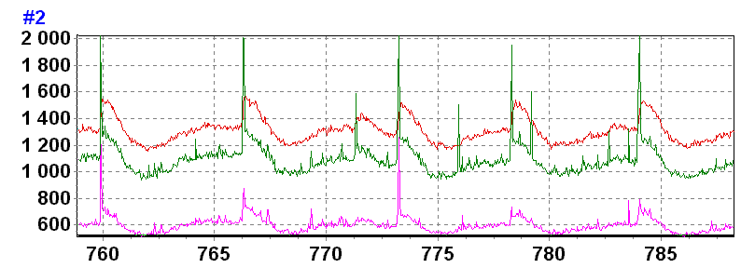
HF, total spectrum

HF, 2 GHz

HF, 4 GHz
F- transformation
o f ECE oscillations

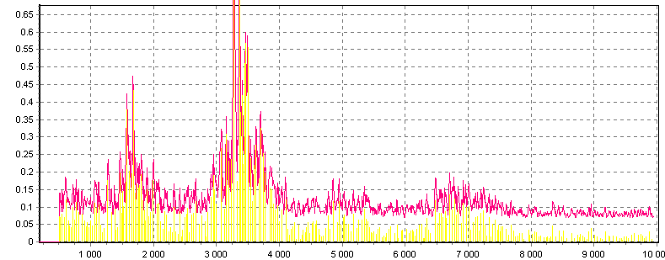
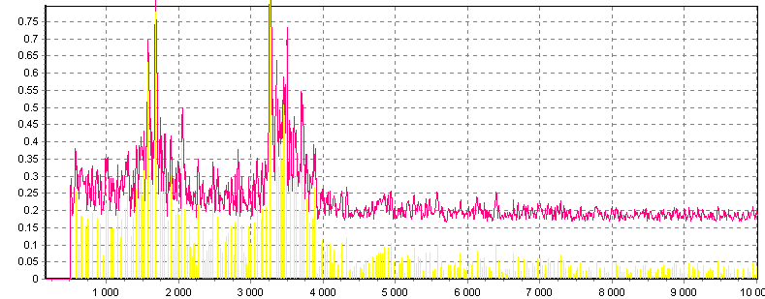
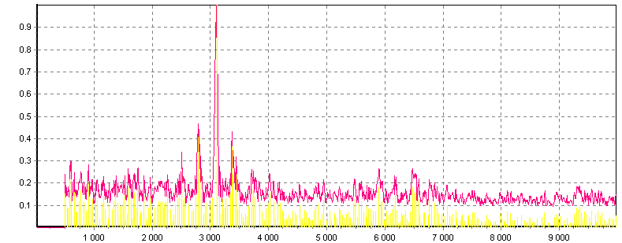
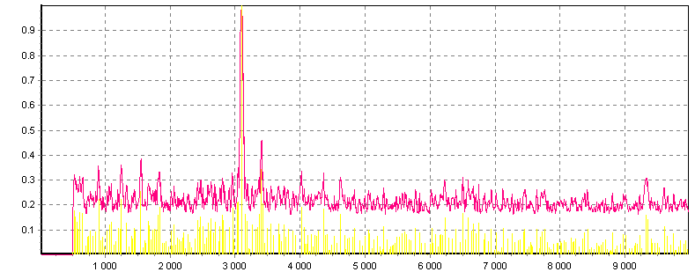
ECE03 – - 7 см
500-600мс

ECE29 – 3 см
500-600мс

ECE27 – 8 см
500-600мс
q=1

ECE22 – 21 см
500-600мс
q=2
Fourier-transformation of ECE
В зонах q=1,2 спектр модуляции содержит квазимонохроматические линии ~ 3, 6 кГц с сателитами +\- 300, 600… Гц

№ 36056. В. Позняк. 250 кА, 25 кГс, 1.5*10¹³см⁻³. 27.12.2002.
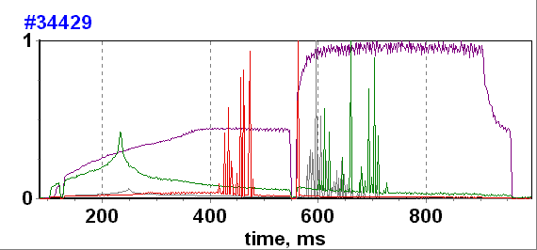
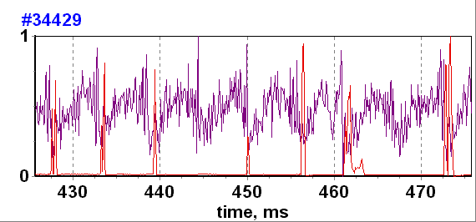
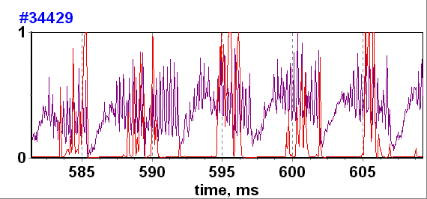
The low frequency spikes are produced during modulating process of sawtooth oscillations in the plasma core (f ~ 3-6 kHz).

Low frequency ECE sharp spikes are emitted by the edge plasma and plasma in the limiter shadow.

ECH

OH

