On Density Dependence of Energy Confinement Time in T-10 Ohmic-Heating Regime
V.A. Krupin, S.V. Krylov, V.G. Merezhkin
NFI, RRC Kurchatov Institue, Moscow, RF, e-mail: vmerej@fusion.ru
Unlike the dependence β_{p} (‾ n_{e}), the experimental dependence τ_{E} (‾ n_{e}) measured in the ohmic-heating regime will not represent interest by comparison with empirical scaling-laws or the separate data achieved on other installations because of ambiguity in these τ_{E} data if they were found at Z_{eff} > 1 and a high level of radiating loss fraction P_{rad}/P_{oh} ≥ 30 %.
To the end of 2004, after improvement of vacuum conditions on T-10 device the OH regimes with a low Z_{eff} = 1.3-1.5 have been received in deuterium discharge in the range of mean density (0.7-4.3) 10¹³ cm⁻³ at plasma current ~ 0.3-0.32 МА, B_{o}= 2.4-2.5 Т, q_{a} ≈ 2.4. With increase in average density the loop voltage increased slowly enough, from ~ 1 up to 1.18 V, and radiating part of loss P_{rad}/P_{oh} increased moderately, up to 25-30 %. At mean electron density ‾n_{e} = 4 10¹³ cm⁻³, the τ_{E} value has reach 60 мс, instead of ~ 43 мс found early [1] at Z_{eff} ~ 2.2 (fig. 1). In Fig. 1, two linear dependences τ_{E} ~‾n_{e}, calculated from neo-Alcator scaling (NA) and from formula proposed in the new paleoclassical theory (PC), are shown as well.
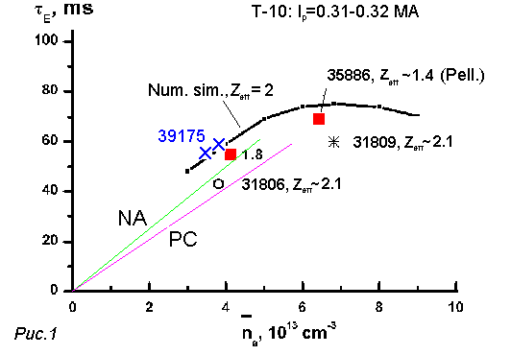
In paleoclassical theory [2], the same formula was found that proposed T. Ohkawa first for electron transport coefficient, but with neoclassical correction to plasma conductivity, which increases the average value of χ_{e} ~ D_{B} ~ (c/ω_{pe}) σ^{NEO}/σ^{SP} by factor of 2 at plasma aspect-ratio R/a ~ 3. Due to this correction (roughly proportional to (r/R) ^{0.75} at ν_{e}* << 1) J.D. Callen has found practically exact correspondence with neo-alcator scaling-law, τ_{E}^{NA} = 0.07‾n_{e} q_{a} R²a, after substitution of the typical value of ⟨T_{e}⟩ = 500 эВ for Алкатор-С device in theoretical formula.
The dependence of χ_{e} on the local ratio ε = r/R resides in T-11 scaling also, but in stronger degree, χ_{e}^{T-11} ~ ε^{1.75}. It is possible to explain the existence of this dependence in χ_{e} to that the trapped electrons, which banana orbit turns out to be unclosed on the distance ~ c/w_{pe} >> Δ_{b}^{e} in the top or bottom their reflection points, are responsible for enhance heat transport in the bulk electrons. In this case, the characteristic frequency of stochastic process should correspond to the bounce frequency 1/τ_{b}^{e} = v_{Te} ε^{0.5} / (2√2 qR) ~ 1 MHz and can be observed in fluctuations in local plasma parameters, such as T_{e}, n_{e} and E_{r}.

References
- V.G. Merezhkin XXXI Zvenogorod Conf. on Plasma Phys. and Cont. Fusion, Zvenigorod, Feb. 16-20, 2004.
- J.D. Callen, 20th IAEA Fusion Energy Conf., Vilamoura, Portugal, November 2004. IAEA-CN-94/TH/1-1.

