STATISTICAL ANALYSIS OF TRANSIENT PLASMA STRUCTURES OBSERVED IN THE PLASMA SHEET BOUNDARY LAYER OF THE EARTH’S MAGNETOTAIL (INTERBALL-1 DATA).
E.E. Grigorenko^{1,2}, L.M. Zelenyi¹, A.O. Fedorov^{1,3}
¹Space Research Institute of RAS, Moscow, Russia
²Skobeltcyn Institute of Nuclear Pysics, MSU, Moscow, Russia
³Centre d’Etudie des Recherchers Rayonnements, Toulouse, France
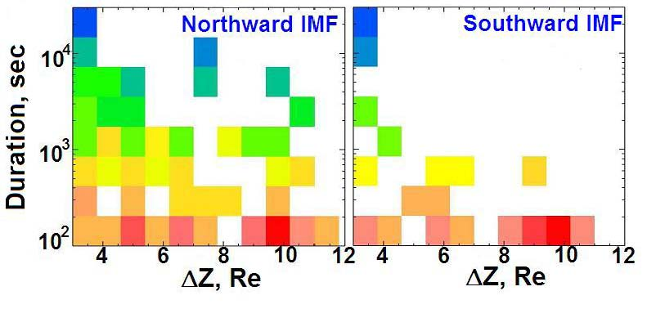
We present the results of statistical study of hot quasi-isotropic plasma structures observed in the Plasma Sheet Boundary Layer of the Earth’s magnetotail. The properties of such a plasma structures (we will call them “plasma clouds”) resemble ones of the Plasma Sheet (PS) but in contrast to the PS, plasma clouds are observed during short time (5-10min). Moreover, in spectrograms measured by Interball-1 plasma clouds are observed as the structures detached from the PS. Unfortunately, 1-point measurements can not respond the question if plasma clouds are really isolated from the PS or they are just manifestations of the PS boundary transient motion. We try to resolve this problem by using the statistical analysis of the distribution of observational probability of PS-like plasma structures (shown by the color in Figure 1, red is maximum) versus the distance from the Neutral Sheet (ΔZ) and event duration. Simultaneously, we would like to reveal the influence of Interplanetary Magnetic Field (IMF) on this distribution. We have found out that during the periods of northward IMF direction, plasma structures with different durations are observed in the magnetotail up to very high ΔZ. This fact may be expalined by the PS extension into magnetotail lobe. But when the IMF has southward direction the pattern is absolutely different. The probability to observe plasma structures with large duration is sharply decreasing with ΔZ (PS thinning) while plasma clouds (with duration ≤10min) are observed with almost equal probability up to very high ΔZ. It is impossible to explain this by PS boundary transient motion. We propose another mechanism of plasma cloud formation under southward IMF.

Fig.1.

