SIMULATION OF ION INTERNAL TRANSPORT BARRIERS BY THE CANONICAL PROFILES TRANSPORT MODEL
Yu.N. Dnestrovskij, S.V. Cherkasov, A.Yu. Dnestrovskij, S.E. Lysenko
Russian Research Centre “Kurchatov Institute”, Nuclear Fusion Institute, Moscow, Russia,
e-mail: dnyn@nfi.kiae.ru
To describe the energy balance in the L-mode in tokamaks, models containing critical gradients of electron and ion temperatures are widely used now. These so-called “first” critical gradients can be found either from the stability margin of drift modes, or from the solution of the canonical profiles problem. To describe the regimes with Internal transport barriers (ITB) we use the idea of a “second” critical gradient. If the pressure gradient exceeds the second critical gradient inside some plasma region then the bifurcation to new state occurs in this region with the transport barrier formation. The discussed dependence of the heat fluxes on the relative pressure gradient is shown in Figure.
This idea is realized in the modified canonical profiles transport model, suitable for energy and particle balance simulation in tokamaks with arbitrary aspect ratio and plasma cross-section. The following criterion of the electron or ion barrier formation is obtained
(a² /r) d/dr ln(p_{k}/p_{c}) > z₀(r) (1)
where r is the radial coordinate, а is the minor plasma radius, p_{k} is the pressure of ion (k=i) or electron (k=e) plasma species, p_{c} is the canonical profile of pressure, z_{0k}(r) = C_{0k} + С_{1k}s are dimensionless functions, which determine the “distance” between first and second critical gradients of ion and electron species, s = r/q dq/dr is the magnetic shear. Coefficients C_{0k} and С_{1k} are determined by comparison of simulations with experimental data. The criterion (1) is close to the experimental one obtained in JET. The developed model predicts that the negative shear diminishes the threshold power needed for the ITB formation.
The experiments with ion ITB on JET, TFTR, DIII-D and MAST were simulated. The optimal values of coefficients C_{0i} = 1, С_{1i} = 2 were found, for which the model gives the reasonable results for all four devices.
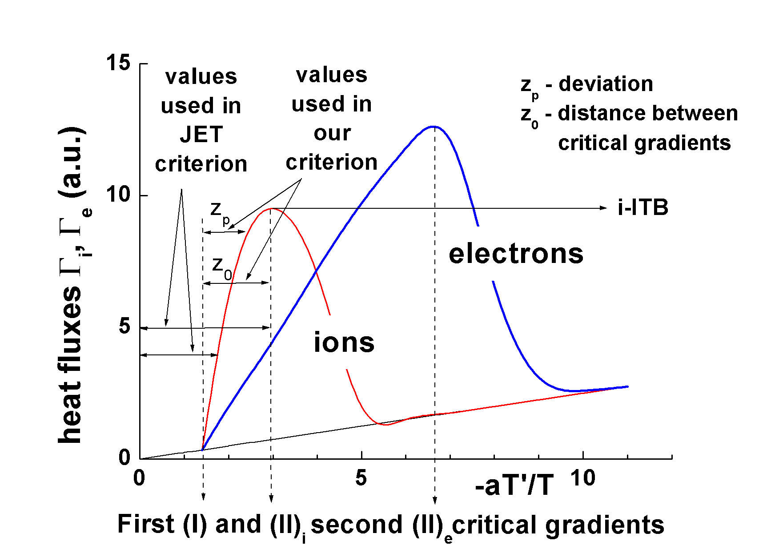
The work was supported by Rosatom, Grant NSh 1608.2003.2 and Contract UKAEA No C010668.

