INVESTIGATION OF CONDITIONS APPEARANCE BRANCHES BOTH CTHODE AND ANODE STREAMER
Krasnochub A.V., Nudnova M.M., Starikovskii A.Yu.
MIPT, NEQ-Lab, Dolgoprudnyi, Russia
For a nitrogen-oxygen mixture (1:4) was carry out experimental investigation of appearance of streamer branching both cathode and anode streamers. We made our experimental in plate-to plate geometry at pressure range from 0.5 to 1.5 bar, under HV nanosecond pulse discharge condition. The voltage amplitude from 20 up to 50 kV, slop 5 ns, duration at half-height 20 ns were transmitted along a coaxial line to discharge gap. An electrical parameters registered by CRS.
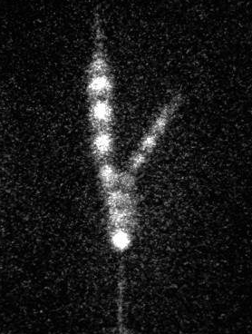 | For registration propagation a streamer through discharge gap we used the stroboscopic regime of ICCD PicoStar HR-12 (LaVision) frequency of strobe is 370 MHz, gate is ~ 900 ps to analyze the velocity and diameter of main channel and branches for different pressures and pulse voltage. On Figure there is a typical result of experiment.  We obtained date about changes under different discharge conditions both the velocity and the radius of streamer head before and after moment of bifurcation.  We found the area (P, U) of existing of branching-form of streamer and we defined parameters of discharge dependence on the boudaryd of this area.
Figure. Streamer branching in N2-O2 = 4:1 mixture. P = 600 Torr, U = 30 kV. Plate-to-plate geometry, h = 30 mm. Stroboscopic regime of ICCD PicoStar HR-12 (frequency of strobe is 370 MHz, gate is ~ 900 ps).

