PHYSICAL MODEL OF GENERATION HIGH-ENERGY PHOTOELECTRONS BY LASER PULSE NEAR METAL SURFACE
M.V. Fedorov, М.А. Yakovlev*
Institute of general physics of the Russian Academy of sciences,
*Moscow State Engineering University named after Bauman
In work [1] had been shown a possibility of influence near-surface electronic stratum on energy of each photoelectron. It had revealed availability to abtain quintaty explanation of found before experimental facts of existence photoelectrons high energy - down to 600 $\text{eV}$[2] at affecting picosecond laser pulses.
In this work made numerical calculation of energy photoelectron spectrum (see picture).
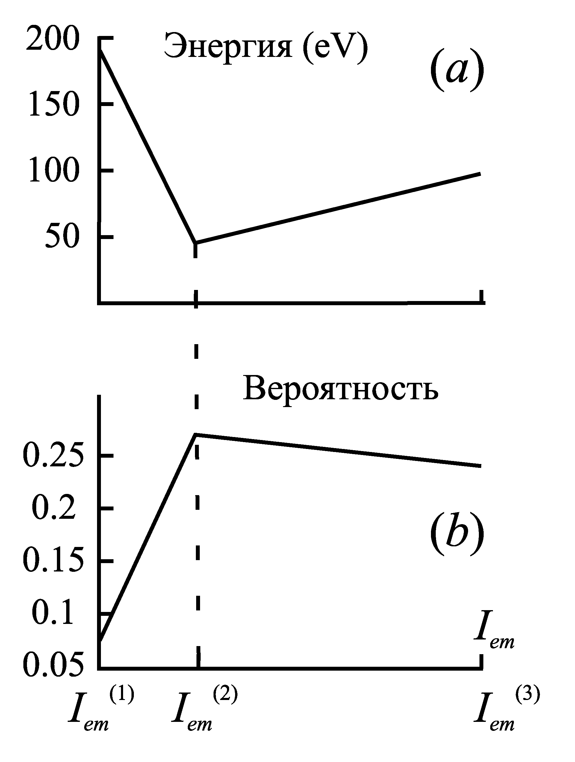

Energy
Probabality

Literature.
- Fedorov M.V., Yakovlev M.A., XXIX Zvenigorod conference on Plazma Physics, 2002, p. 214.
- Gy. Farkas, Cs. Toth, Phys. Rev. A, 41, 4123 (1990).
Authors
Fedorov Michail Vladimirovich, Doctor phis.-mat. Science, General Physic Institute Russia;
w.tel. 1328257
Yakovlev Mikhail Alekseevich, Professor, d.ph.-m.n., MSTU named after Bauman, Russia;
Home adr.: 127474, Moskow Dmitrovskoe shosse 76,105;
W.tel. (095) 263-64-25, H.tel. (095) 487-62-43, E-mail: yakovlev@mx.bmstu.ru

