FAST TURBULENT HEATING OF HEAVY IONS IN PLASMA WITH TWO SPECIES OF IONS.
I.V. Kuzora, V.P. Silin, S.A. Uryupin
P.N. Lebedev Physical Institute RAS, Moscow, Russia, e-mail: kuzora@sci.lebedev.ru
Ion-acoustic turbulence (IAT) in plasma results in effective heating of bulk ions with velocities less than ion-acoustic velocity (see, for example, [1, 2]). In the IAT theory the heating of ions is associated with stimulated scattering of ion-acoustic waves by ions [3, 4]. Recently [5, 6] a theoretical description of the IAT in plasma with two ion species was given and new properties of the stimulated scattering of waves by ions were established. In the present work the turbulent heating of ions is studied for plasma with the IAT and two species of ions. It is shown that the stimulated scattering results in an unequal distribution of wave energy between the two ion species. In particular, the interesting phenomenon of fast heating of a heavy ion admixture is predicted. To illustrate this phenomenon below the graph of time dependencies of light (hydrogen) and heavy (oxygen) ion temperatures is given for the fully ionized HO-plasma, n_{O}/n_{H}=8%. Here t_{H} – is the characteristic time of the light ion temperature doubling.
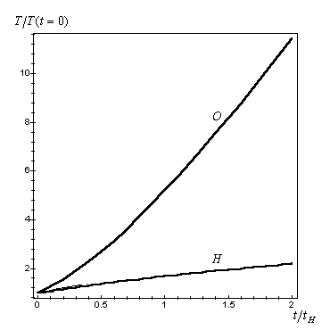References.
- E. K. Zavoiskii, L. I. Rudakov, At. Energ. 23, 417 (1967).
- E. D. Volkov, N. F. Perepelkin, V. A. Suprunenko, E. A. Suhomlin, Collective Phenomena in Current-Carrying Plasma, Naukova Dumka, Kiev, 1978.
- B. B. Kadomtsev, in: M.A.Leontovich (Ed.), Reviews of Plasma Physics, Atomizdat, Moscow (1964) (in Russian); Consultants Bureau, New York, (1968) (in English), Vol. 4 p. 258.
- V. I. Petviashvili, Sov. Phys. Dokl. 8, 1218 (1964).
- V. P. Silin, S. A. Uryupin, Sov. Phys. JETP 75, 78 (1992).
- I. V. Kuzora, V. P. Silin, S. A. Uryupin, JETP 93, 1035 (2001).

