Investigations OF THE SPECIFIC OSCILLATIONS WITH FREQUENCIES NEAR 20 KHZ BY HIBP
L.G. Eliseev, A.V. Melnikov, V.A. Mavrin, L.G. Zimeleva, S.V. Perfilov, M.V. Ufimtzev*, L.I. Krupnik**, HIBP Team**
Nuclear Fusion Institute, RRC "Kurchatov Institute", 123182, Moscow, Russia,
e-mail: melnik@nfi.kiae.ru
*Department of Computational Mathematics and Cybernetics, Moscow State University, Moscow, Russia,
**Plasma Physics Institute, National Scientific Center “Kharkov Physical Technical Institute”, Kharkov, Ukraine, e-mail: hibp@ipp.kharkov.ua
Investigations of the specific oscillations with frequencies 15-30 kHz on the T-10 tokamak (R = 150 cm, a = 30 cm) with the with Heavy Ion Beam Probe (HIBP) diagnostics was continued [1] in regimes with ECR plasma heating (B₀ = 2.33 T, I_{pl} = 220 kA).
Previous experiments in the regimes with Ohmic heating [1] have shown that 20 kHz modes are mainly the potential fluctuations. These oscillations exist on the signals of HIBP, Langmuir probes and reflectometry They should cause the fluctuations of the poloidal rotation, i.e. the torsional oscillations of the plasma with m=0, called as the zonal flows.
Evolution of the “20 kHz” mode on the plasma potential in regimes with off-axis ECRH (power deposition zone ~ 12 cm) is presented in this report. HIBP sample volume was localized out the ECRH region in the area r = 25 cm. Increase of the frequency is observed when ECRH turns on (Fig.1). This frequency change is correlated with change of the electron temperature, measured by 2nd harmonic of EC (Fig.2), on nearest chord 24 cm. Data analysis have shown that frequency of the “20 kHz” mode is proportional to square root of the local Te (Fig.3). This dependency allows us to suppose these oscillation to be linked with Geodisic Acoustic Mode [1, 2] witch is characterized by such dependency
$$ν_{\text{GAM}}\text{\sim }\frac{c_{s}}{R}\text{\sim }\sqrt{T_{e}}$$
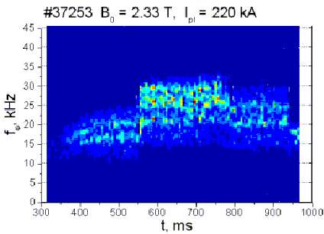
Fig.1 Fig.2 Fig.3
This work was supported by Minatom RF, RFBR grants 02-02-17727, RFBR МАС 02-02-06609, НШ-1608.2003.2, INTAS 2001-2056, NWO-RFBR 047.009.009.

References
- A.V. Melnikov, V.A. Vershkov et al, EPS-30, St.Petersburg, Russia, ECA Vol. 27A, P-3.114
- G.R. McKee et al, EPS-30, St.Petersburg, Russia, I-5.6 (P-4.238)

