APPLICATION OF THE CANONICAL PROFILES THEORY FOR CALCULATION OF THE TEMPERATURE GRADIENT SCALING IN TOKAMAKS
Yu.N. Dnestrovskij, A.Yu. Dnestrovskij, S.E. Lysenko, S.V. Cherkasov
RRC ‘Kurchatov Institute’, Nuclear Fusion Institute, Moscow, Russia,
e-mail: dnyn@nfi.kiae.ru
In our previous paper [1] the theory of canonical profiles, developed by B.B.Kadomtsev for circular cylindrical tokamak plasma [2], was generalized. We obtained the equation for the canonical profile of μ(r) = 1/q in the toroidal plasma with arbitrary cross section, any aspect ratios A, and “soft” and “stiff” boundary conditions. Now we include this generalized canonical profiles model into the transport code ASTRA. The heat flux Q consists of two terms: Q=Q_{an}+Q_{PC}; where Q_{an}= -nχ_{an}∂T_{e}/∂r and describes the anomalous transport, Q_{PC}= -nχ_{PC}(T/R)(Ω_{Te}-Ω_{c}), Ω_{Te}= -RT_{e}′/T_{e}, Ω_{c}= -RT_{c}′/T_{c} is the critical gradient of the canonical temperature profile. The model was validated over some tenth of shots from various tokamaks (mainly with the L-mode), containing in the ITER database [3]. We compare calculated and experimental profiles of the electron temperature T_{e} and T_{x}, and found a good correlation between Ω_{Te} and Ω_{Tx}= –RT_{x}/T_{x} (Fig. 1). Calculations have shown that the average linear deviation T_{e} from T_{x} is less than 25%, but normalized deviation is twice as lower. This means that our model better describes the gradients than the absolute values of the temperature. In the Kadomtsev model (A→∞), the relative critical gradient depends on combination of dimensionless parameters Ω_{c} = ¹⁶/₃⋅Aq/(q+4). In our model the canonical profile depends on A, q, elongation k and triangularity δ, therefore as a first approximation for creation of the scaling for the relative temperature gradient we propose following combination for the scaling parameter: ξ=qA²/(k(q+4)). Figure2 shows the scaling Ω_{Te}(ξ), which allows us to predict the relative profiles of the electron temperature in tokamaks.
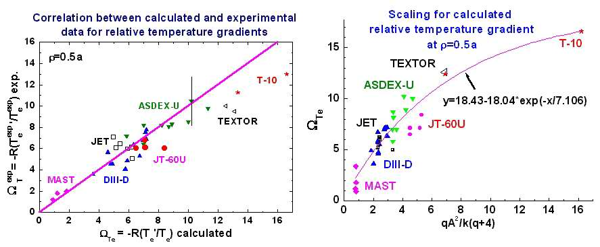
The work was supported by DAST of Minatom RF, RFBR grant 00-15-96536 and UKAEA Agreement QS06588.

References
- Dnestrovskij Yu.N. et al. Plasma Phys Repts 2002, v. 28, p. 887.
- Kadomtsev B.B. Sov J. Plasma Phys 1987, v. 13, p. 251.
- http://tokamak-profiledb.ukaea.org.uk/

