SIMULATING PROCESS OF GENERATING OF DENSE NEAR-SURFACE LOW TEMPERATURE PICOSECOND PLASMA.
Yakovlev.M.A
The Moscow State Engineering University Named after N.Bauman, 107005, Moscow, 2-я Baumanskai, 5; Ph.: (095) 2636425; е-mail: yakovlev@mx.bmstu.ru
Now considerable concern to technological applying of powerful lasers in a condition of ultrashort impulses pico and femtosecond of ranges is bound(interlinked) to advance in precision treating of metallical surfaces by ultrashort laser impulses. The relevant role on happening near-surface processes renders the composition and physical properties of enclosing gas .
In the present report the outcomes of numerical calculation of the process of a near-surface breakdown of different dense inert gases were above the metallical target are resulted with allowance for influencings of a near-surface electronic stratum.[1]
The outcomes are reduced on the profiles:
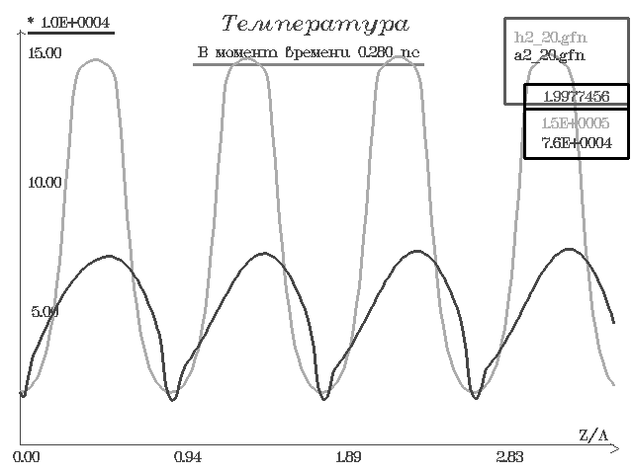
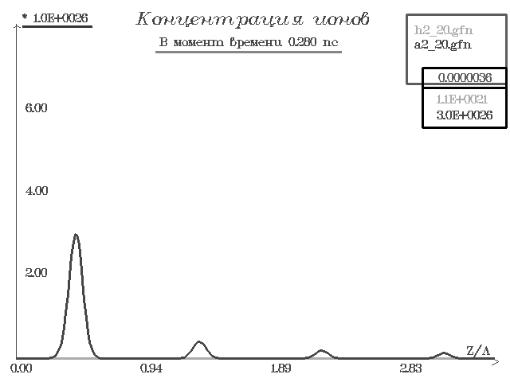
On reduced above figures the following identifications will be utillized:
h – helium, a – argon, Amplitude e/m of a surge 2·10⁹ V/m
Concentration of near-surface gas 20·10²⁷ м⁻³
From obtained outcomes follows, that a pacing factor, defining nature of the process of plasma formation, is the magnitude of a potential of ionization. It is visually visible from the profiles for temperature and concentration of generatrix plasma. The gases with a major potential of ionization under the same conditions are heated to greater temperature, as they practically have energy ionization losses, as against gases with a smaller potential of ionization is it is visually visible at matching the profiles for He with a potential of ionization I=24.59 eV and Ar with a potential of ionization I=15,76 eV.

Literature.
- М.A. Yakovlev, // JETP.2002. Т.122, 814-819.

