Interelectrodes « dusty » matter in vacuum discharge as x-rays, fast ions and neutron source

Yu.K Kurilenkov ¹, M. Skowronek²

¹Institute for High Temperatures (IVTRAN), Russian Academy of Sciences, Moscow 127 412,
²Laboratoire des Plasmas Denses, Universite P.& M. Curie, F-75252 Paris Cedex 05, France
( ykur@online.ru msk@ccr.jussieu.fr)

We study experimentally and theoretically the high power density random media (ensembles of cold grains with small fraction of hot microplasmas) generated in vacuum discharges with hollow cathode at low energy ( ~ 1 J ). This ensembles are created by an intense energy deposition into the cold solid density, very low volume dusty “target“ collected in interelectrode space (clusters, grains, microparticles of different size from anode material). In particular, hard x-rays emission efficiency, generation of energetic ions ( ~ 1 MeV), trapping of fast ions or/and x-rays, energy transport and other features of x-rays “dust” media as a simple power source of hard x-rays or energetic particles are the subject of our study [ 1].
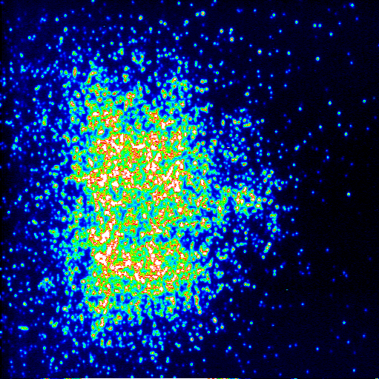

Fig.1. Hard x-rays CCD camera image of interelectrodes dusty matter for shot with low neutron yield , ~ 10 ⁵ .per Joule
Thermal and suprathermal levels of x-ray emission, laser-like behaviour of potentially amplifying media of plasmas "dust" as well as x-ray trapping have been demonstrated earlier [1]. Last one scheme assumes partial “random walk” of photons [2] inside of x-ray “ball” due to regulated level of multiple scattering and reflecting in disordered or self-organized (correlated) media [1]. Partial trapping of x-rays allows some experimental simulations of the x-ray transport and related processes in clusters of stars (x-rays and gamma-rays bursts, “cluster of stars” as random lasers, etc). The further steps like generation of neutrons as well as some modelling of elements of interstellar burning will be discussed in the present work.
Neutron generation in x-rays ensembles have been registered using the same experimental set-up [1] as for x-rays and fast ions studies. We have used particular modified Pd electrodes with deuterium doping (by rechargeable manner). Time of flight (TOF) measurements with photomultipliers (PM) located along the axes have been performed. PMs were covered by scintillators and located under different distances (within one meter) from source. Beyond of x-rays (first strong peak), PM indicate the well reproducible signal with typical delay about 46,6 nsec/ meter, that may correspond to neutron yield related with D+D reaction (analogously to laser irradiated deuterium clusters [3]). The changing of the distances between source and PM provokes correspondent moving of second peak. The simultaneous (with TOF scheme) using of CR39 and PN3 plates (as well as the way to develop them) show the variable number of tracks (above the known background number) which have to be attributed with neutrons also.
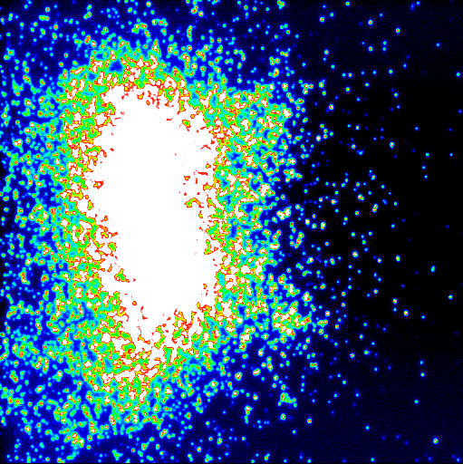

Fig.2. Hard x-ray image for discharge with higher neutron yield, ~ 10⁶ - 10⁷ per Joule.
Summing up, the magnitudes of particular TOF's peaks measured by PMs, numbers of tracks related at PN3 plates, intensities of hard x-ray CCD images registered are in good and reproducible correlation. Number of tracks is growing with number of shots also. The value of neutron yield from random interelectrode "dusty" media is variable one, being about 10⁵ - 10⁷ per shot under about 1 J of total energy deposited to create all the discharge processes at the single shot . The typical examples from x-rays data base of images for interelectrodes dusty matter with neutron yield are shown at figs 1,2. (In terms of [4 ], we study here the specifics of ensembles of microparticles with fraction of anodes "ectons" and related elements of microexplosive nucleosynthesis.) Average efficiency of neutron production is higher than for laser irradiated clusters ( 10⁴ neutrons for 120 mJ of laser energy [3]). However , the random nature of x-rays ensembles may influence the reproducibility of neutron yield being a subject of further study. Nevertheless, hopefully, that simple nsec scale discharge scheme suggested to produce neutrons may supplement available novel efficient approaches like based on laser excitation and hydrodynamic dissipation of foam-like targets [ 5 ] as well as on laser initiation of other nuclear reactions by energetic ions (sf [6]).
We acknowledge partial support of this work by Russian Foundation for Basic Research Gr. 98-02-18290. We would like to thank also Nuclear Enterprise Tech Ltd, England, and Tours Technopole and O.P.R.I., France, for developing of PN3 and CR39 plates and help in analysis of tracks.

- Yu.K Kurilenkov, M. Skowronek, G. Louvet, A.A. Rukhadze, J.Dufty. Journal de Physique IV, 10 (2000), Pr5-409; Yu.K Kurilenkov et al, Plasma Physics Conference, Section IV, Zvenigorod 2000.
- V. S. Letokhov, Sov. Phys. JETP, vol. 26, no. 4, pp. 835–840, 1968
- T. Ditmire et al, Nature (London) 398, 489 (1999) ; J.Zweiback et al, Phys. Rev.Lett. 84, 2634 (2000).
- G. A. Mesyats, Ectons in vacuum discharge: breakdown, the spark, and the arc. -M. Nauka, 2000.
- С.Ю. Гуськов, Н.В. Змитренко, В.Б. Розанов. Письма в ЖЭТФ, 1999, т.66, вып.8, с.521-526.
- В.Ю. Быченков, В.Т. Тихончук, С.В. Толоконников. ЖЭТФ, 1999, т.115, вып.6, с.2080-2090.

