Filamentation of subpicosecond pulses of UV radiation generated at Ti:Sapphire/KrF laser system GARPUN-MTW
V.D. Zvorykin, A.A. Ionin, A.O. Levchenko, L.V. Seleznev, D.V. Sinitsyn, I.V. Smetanin, N.N. Ustinovskii, A.V. Shutov
P.N. Lebedev Physical Institute of Russian Academy of Sciences, Moscow, Russia, zvorykin@sci.lebedev.ru
Experimental technique was developed and applied to investigate multiple filamentation of UV subpicosecond pulses amplified at hybrid Ti:Sapphire/KrF laser facility GARPUN-MTW [1] under their propagation along an extended air distance of ~100-m length. Peak pulse power in these experiments attained 0.5 TW, being in 5000 times higher than the critical power of filamentation (~10⁸ Вт) for a wavelength λ=248 nm. Laser beam was focused by all-reflecting mirror system with a numerical aperture of about 3 10⁻⁴ at 60-m distance from the final amplifier. A luminescence of thing plane plate of K8 glass under UV irradiation was imaged onto “Videoscan-285” CCD camera with time integration over 100 ms. Multiple bright spots of typical diameter ~0.1 mm are distributed over all cross section area of the laser beam (Fig. 1) which evidences about multiple small-scale filamentation.
а | b | с
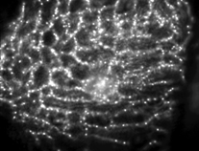 | 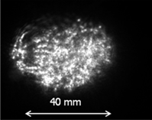 | 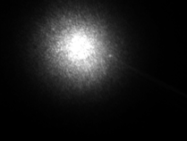
Fig. 1. Distribution of energy density UV radiation over cross section of the laser beam at different distances from the focus 40 m (а); 30 m (b) and in focus (с).
Beam filamentation arose immediately at an output of the final amplifier. Filaments were grouped near heterogeneities of the beam being caused by a blocked structure of amplifier windows manufactured of calcium fluoride (а). A density of filaments increased with beam focusing (b) and near the focus they were indistinguishable because of overlapping (c). Behind the focus in the expanding beam filamentation structure appeared again although it was not so clear. In spite of a multiple small-scale filamentation, the whole UV laser beam was submitted to usual focusing geometry. The similar filamentation behavior was observed for UV laser beam focused by the mirror with F=8 m which has been applied earlier for the effective HV electric discharge guiding [2]. It is in contrast to the filamentation of IR radiation with λ~800 nm where an extended region does exist where nonlinear Kerr self-focusing compensates the divergence [3].
This work was supported by RFBR Projects 11-02-01414, 11-02-01524 and 11-02-12061-ofi-m, as well as by EOARD Project 067007 (ISTC Project 4073 Р).
References
- Zvorykin V.D., Levchenko A.O. and Ustinovsky N.N., Quantum Electron., 2010, 40, 381.
- Ionin A.A., Kudryashov S.I., Levchenko A.O., et al., 2012, 100, 104105.
- Couairon A. and Mysyrowicz A., 2007, Physics Reports, 441, 47.

